

Software Engineering  
Section 07, Sem.2 2014/2015

**SOFTWARE DESIGN DOCUMENTS (SDD)**

**Organization’s Name:**

Lembaga Pertubuhan Peladang Kawasan Johor Bahru Timur

**Team Name:**

TEAM REVIVAL

**System’s Name:**

File Searching System

**Team Members:**

1. Abdullah Azzam (A13CS4002)
2. Chan Vei Siang (A13CS0019)
3. Ikmal Faiq Albakri Bin Mustafa Albakri (A13CS0182)
4. Nur Aliya Safura Binti Mohd Ghazali (A13CS0102)
5. Nurfarrah Liana Binti Sa’adon (A13CS0120)

|  |  |
| --- | --- |
| **Criteria** | **Marks** |
| **Document Preamble** (adequate introduction that describe the objective, scope, and content of the document) | /10 |
| **Architecture Design Decision Justification**  Ensure that all the Architecture Design Decision Question have a suitable justification | /25 |
| **Data Dictionary correctness** (check for any missing data related to the proposed topic/system) | /10 |
| **Data Correctness & Completeness**   * (check for missing class diagram or packages to the proposed topic/system) * (ensure that the notations and semantics are correctly presented in the architectural design, class diagram, state transition diagram, package) | /15 |
| **User Interface Design**   * Screen Layout * HCI Design Quality | /15 |
| **Supporting Documents/Artifacts** (adequate number of appendices that represent the current system document, reports etc. such as receipt, invoice, registration form, etc.) | /10 |
| **Overall Document Quality** (the report using the right format, well-presented, very minimum typo errors, etc.) | /15 |
| **TOTAL** | /**100** |

Table of Contents

1. Introduction 4

1.1 Purpose 4

1.2 Scope 4

1.3 Overview 5

1.4 References 6

1.5 Definitions, Acronyms, and Abbreviations 6

2. System Overview 8

3. System Architecture 9

3.1 Architecture Design Decision 9

3.1.1 Architectural Style 10

3.1.1.1 Model-View-Controller (MVC) Architecture 10

3.1.2 Control Strategy 11

3.1.2.1 Centralized Control Model: Manager Model 11

3.2 Decomposition Description 11

3.2.1 Model Component 11

3.2.2 View Component 12

3.2.3 Controller Component 13

3.3 Design Rationale 14

3.3.1 Reasons 14

3.3.2 Advantages 14

4. Data Design 16

4.1 Data Description 16

4.2 Data Dictionary 17

5. Component Design 19

5.1 Use Case 19

5.2 Sequence Diagram 20

5.2.1 Search for File 20

5.2.2 Borrow File 21

5.2.3 Returning File 21

5.2.4 Produce Report by File Category 24

5.2.5 Produce Report by File Type 25

5.2.6 Produce Report by Borrower List 26

5.2.7 Managing File by Adding New File 27

5.2.8 Managing File by Edit Existing File 28

5.2.9 Managing File by Remove Existing File 29

5.2.10 View File Borrowed History 30

5.2.11 Produce Checklist by Date of Edited 31

5.2.12 Produce Checklist by File Location 32

5.3 Class Diagram 33

5.3.1 Class Diagram for Search for File 33

5.3.2 Class Diagram for Borrow File and Return File (Basic Flow) 34

5.3.3 Class Diagram for Return File (Alternative Flow) 35

5.3.4 Class Diagram for Produce Report 36

5.3.5 Class Diagram for Add New File 37

5.3.6 Class Diagram for Edit Existing File 38

5.3.7 Class Diagram for Remove Existing File 39

5.3.8 Class Diagram for View File Borrowed History 40

5.3.9 Class Diagram for Produce Checklist 41

5.4 State Transition Diagram 42

5.4.1 File State Transition Diagram for Borrow and Return File Scenario 42

5.4.2 Borrow File List State Transition Diagram for Borrow and

Return File of Each User Scenario 42

5.4.3 Search File State Transition Diagram for Searching File Scenario 43

5.4.4 Add File State Transition Diagram for Add New File Scenario 43

5.4.5 Edit File State Transition Diagram for Edit Existing File Scenario 43

6. User Interface design 45

6.1 Overview of User interface 45

6.2 Screen Images 46

6.2.1 Login Page 46

6.2.2 Home Page 47

6.2.3 Search File Page and Search Result Page 49

6.2.4 File Information Page 50

6.2.5 Rented File Page 51

6.2.6 Produce Report Page 52

6.2.7 Add File Page 54

6.2.8 Edit File Page 54

6.2.9 Remove File Confirmation Page 55

6.2.10 View History Page 55

6.2.11 Produce Checklist Page 56

7. Appendices 59

# Introduction

## Purpose

This system design document describes the architecture and system design of our File Searching System developed for Lembaga Pertubuhan Peladang Kawasan Johor Bahru Timur (LPPKJBT). It will be the design process for identifying the sub-systems making up a system and the framework for sub-system control and communication. It is an early stage of the system design process for our system development.

The goal of this document is to enable the developer that is unfamiliar with this system to be able to read the document and get the clear idea of the system’s design. This document is divided into three major parts: system architecture, software design and system user interface.

The software design specifies the main software components that operate under, and support the system architecture. System user interface is represented for a clear display on the system implementation.

## Scope

File Searching System is a system that will provide file searching mechanisms for Lembaga Pertubuhan Peladang Kawasan Johor Bahru Timur (LPPKJBT) as a stand-alone and computerized system, which does not need to interact with other applications and using its own database. Only registered personnel (employee, manager, file manager) can use the system.

Every personnel can search for the file location to borrow or return the file.

Manager can produce report based on the number of each file category, or file type, as well as to generate report of the current borrower of the file.

File manager can add, edit and remove file by using the system. He or she can also generate a list of checklist to help in organizing the file cabinet. Besides that, the file manager can view the borrowed history of every file to trace all the former and current borrower of the file.

## Overview

This Software Design Documentation is organized as follows:

|  |  |
| --- | --- |
| Section | Purpose |
| Section 1: Introduction | To explain the background of the system |
| Section 2: System Overview | To describe the purpose of the system, and provide a conceptual design. |
| Section 3: System Architecture | To present the system architecture of File Searching System by viewing the system from various perspectives. |
| Section 4: Data Design | To describe the type of data model that is being used in File Searching System including the data description and data dictionary, and how it interacts. |
| Section 5: Component Design | To describe the class diagram in each layer and also to describe a state transition diagram based on the SRS. |
| Section 6: User Interface Design | To represent the system user interface of the system. |

## References

Background & roles of LPPJB*. Official Portal of Farmer’s Organization Authority*. Retrieve from http://www.lpp.gov.my/en/farmers-organization-introduction.

Sommerville, I. (2007), *Software Engineering, 8th Edition*, United States: Pearson, p.115-118

Li, J. H., Meng, F. X., Wen, X. M., & Zhang, J. K. (2012). The Design and Realization of Library MIS Based on MVC. *Proceedings of the 2012 2nd International Conference on Computer and Information Application (ICCIA 2012)*. Paris: Atlantis Press, p.1620-1623.

Azzam, A., Chan. V. S., Albakri, I. F., Safura, N. A., & Liana, N. (2015). Software Requirement Specification, Version 1.0. Johor Bahru: Universiti Teknologi Malaysia

## Definitions, Acronyms, and Abbreviations

|  |  |
| --- | --- |
| “SRS” | System Requirement Specification |
| “FSS” | File Searching System |
| “LPPKJBT” | Lembaga Pertubuhan Peladang Kawasan Johor Bahru Timur |
| “File” | The physical file that is kept in the cabinet. |
| “Serial number” | The unique number of each file. |
| “Closed-file” | The file that already reach 100 pages, but is not discarded. It is stored in the closed-file cabinet. |
| “File type” | The type of file in the organization, which include public file and private file.  Public file is the file that can be viewed by every personnel in the organization, while private file is the file that can be viewed by “manger” and “file manager” personnel only. |
| “File category” | The category of file, which include employee record, company report, and closed-file. |
| “Employee” | The registered low-level management personnel in the organization, which can borrow public file type. |
| “Manager” | The registered higher-level management personnel in the organization, which can borrow any file type, as well as produce the report from the system. |
| “File manager” | The registered specialized personnel in the organization that is responsible to manage this system, which can add, edit and remove the file information, as well as produce the checklist and view file borrow history. |

# System Overview

The FSS will feature the library management domain application, as it can helps the organization to search for a physical file (paper file) from the cabinet more effectively and efficiently. It also provided graphical user interface for interactive communication between the user and the system. This will improve the productivity of the LPPKJBT.

The FSS will be a stand-alone system and will retrieve required information from its own database. Only registered personnel, such as employee, manager and file manager, can use the system.

The system will provide the organization with the mechanisms to improve the user experience to search for file, as it will provide accurate location of the requested file. The borrow file process as well as return file process also are reduced, because the user doesn’t need to record his or her information manually, as the system will help the user update the information in the database automatically.

The manager can get advantages from this system as well. The FSS is able to generate report, such as the total number of each file type, the total number of each file category, and a list of current borrower, as requested by the manager. The report will help in the decision-making process.

Besides, the file manager will be able to edit the file information and to produce a checklist that will help the file manager to manage the file cabinet. The file manager can also view the borrowed history of each file.

# System Architecture

## Architecture Design Decision

Summary of the architecture design decision of FSS:

|  |  |
| --- | --- |
| What approach will be used to structure the system? | 4+1 view architecture  -Design view  -Implementation view  -Process view  -Deployment view  -Use Case View |
| What architectural style is appropriate? | Model-View-Controller (MVC) Model.  Model component manages the system data.  View component manages the presentation of data to the user.  Controller component manages user interaction and passes these interactions to the View and Model. |
| What control strategy should be used? | The Manager Model of centralized control strategy. |
| How will the structural components be decomposed into sub-components? | The structural component can be decomposed into sub-components using object oriented model. |
| Is there a generic application architecture that can be used? | Transaction processing applications. It can process user requests for information from database or update the database, such as search file and edit file. |
| What architectural organization is best for delivering the non functional  requirements? | Security: Different view for different user type. Some files are protected from certain employees.  Reliability: Run query based on user’s input, and display accurate information. |

### Architectural Style

#### Model-View-Controller (MVC) Architecture

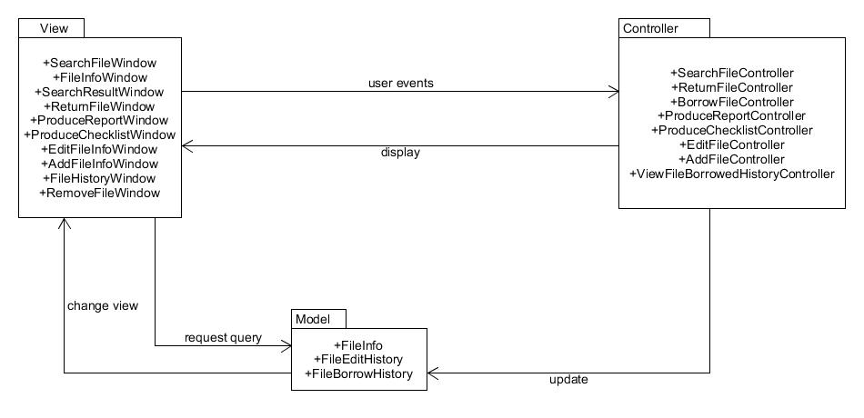

Figure 1: MVC Architecture Style

### Control Strategy

#### Centralized Control Model: Manager Model

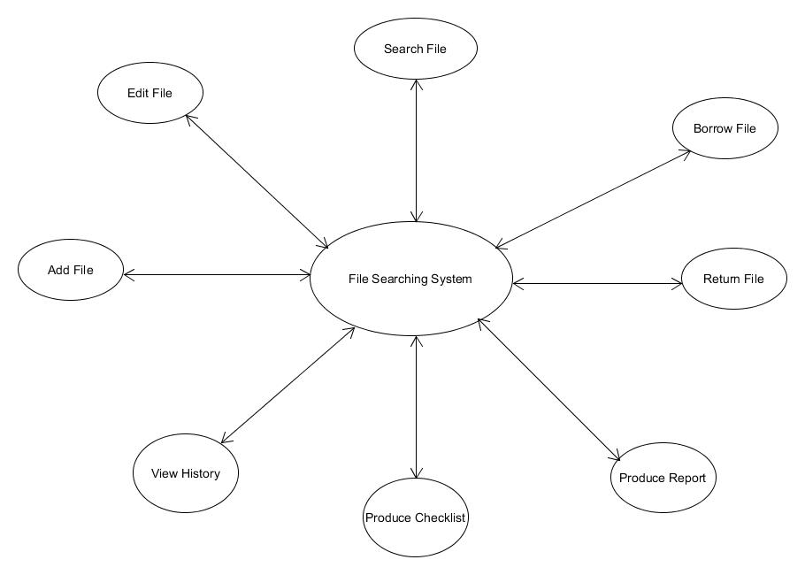

Figure 2: Centralized Control Model: Manager Model

As shown in figure above, the centralized control strategy is used to control the flow between sub-systems. The FSS manager will act as the manager component, which responsible to manage the operation of other system processes. The common processes in the FSS are manage login, search file, borrow file, return file, produce report, produce checklist, view borrow history, add file, and edit file. This is also known as manager model.

## Decomposition Description

### Model Component

The model manages the behaviour and data of the FSS, responds to the requests for information query, and responds to the instruction from the controller to change status, such as file availability. For example, once the user borrows a file, the user information and the file borrowed will be recorded in the borrower list, and change the file availability to not available.

As shown in Figure, the model component consists of three packages:

1. FileInfo: Manage the file information in the database.
2. FileEditHistory: Manage the file edit history in the database.
3. FileBorrowHistory: Manage the file borrowed history in the database.

### View Component

The view represents the user interface. It can be described as HTML for Web application. The view translates the model into a form that is suitable to interact with the users, such as input form, table or list, button, and any other user interface elements. Multiple view can exist for a single model for different purpose, for example the views between employee and file manager are different in the file information window, as file manager can do more function than employee to the file information.

From Figure, there are ten packages in this component:

1. LoginWindow: Allow the user to log in to the system by using registered username and password.
2. SearchFileWindow: Allow the user to enter the requested file name, file id and file category in a form.
3. SearchResultWindow: Display the search results in a form of table.
4. FileInfoWindow: Display the file information to the user, as well as to allow user to borrow or return the file in the form of button. As for file manager, he/she can choose to edit the file information and view the file borrowed history.
5. ReturnFileWindow: Display the current borrowed file by the user.
6. ProduceReportWindow: Allow the manager to choose the type of report need to produce.
7. ProduceChecklistWindow: Allow the file manager to produce the checklist based on the type of checklist.
8. EditFileWindow: Allow the file manager to edit the information of the file, which is display as an input form.
9. AddFileWindow: Allow the file manager to add new file to the system, which is display as an input form.
10. ViewFileBorrowedHistoryWindow: Allow the file manager to view a list of former borrowers and current borrower of the file.

### Controller Component

The controller get the user request and match model with view to complete the user’s request. For example, once the user enter the requested file name, the controller will passed the information from the model to the view to display a list of file that has the related name to the user. The controller can act as a dispatcher (Li et al., 2012) to choose the type of models as well as the type of views, and to fulfil the user requests. It accepts user request and tell the model and view to perform actions based on the request.

In Figure, there are eight packages in controller:

1. SearchFileController: Send query to the model to search for the related file information in the database and tell the view what to display.
2. BorrowFileController: Update status of the file and borrower in the model.
3. ReturnFileController: Update status of the file and borrower in the model.
4. ProduceReportController: Send query to the model to search for the information in the database and tell the view what report to display.
5. ProduceChecklistWindow: Send query to the model to search for the information in the database and tell the view what checklist to display.
6. EditFileController: Send query to the model to update the fields of file information in the database.
7. AddFileController: Send query to the model to insert a new file information in the database.
8. ViewBorrowedHistoryController: Send query to the model to search for the information in the database and tell the view to display the borrowed history of the selected file.

## Design Rationale

### Reasons

In MVC architecture style, the FSS is divided into separate and unique logical components that interact with each other, such as model, view and controller. This style allows separate presentation and interaction from the system data. In the system, the view act as the user interface and the business logic can be represented by the controller, while the model act as the database. So, the data can change independently from its representation. Besides, the system can have multiple ways to view and interact with data, as MVC supports the presentation of the same data in different ways and a changes is made in one representation will also change the representation of the others.

### Advantages

#### Abstraction

Components allow changes to be made at the abstract level. We can insert or remove the abstraction without changes the other components. It is beneficial to the division deployment (Li et al., 2012) as well, because the deployment of Web application in PHP and JavaScript, the programmer only need to focus on the business logic (the controller), while the user interface programmer, such as HTML, will concentrated on the view.

#### Reusability

For example, in the File Information Window, different user access this Web page will have different view, but the business logic of the system is still the same. For example the file manager can uses more features and that are edit the file information and view the borrowed history, besides borrow and return the file like the other employees did. The view component is reused and is changed the way of representation by the controller.

#### Maintainability

Reduce coupling to help separate the presentation and business logic effectively and hence improve maintainability. Therefore, any changes made in the business logic cannot affect the code of the presentation; the developer also can modify the code of presentation freely, and no need rebuild the code of the model and the controller (Li et al., 2012).

# Data Design

## Data Description

1. jobID

* Contain the job’s id number. It will be used to set the view of system interface as Employee, Manager, or File Manager.

1. jobName

* Contain the job’s name. To describe the user status in organization.

1. userID

* Contain the user’s id number. It will be used as identifier.

1. userName

* Contain the user’s name. The user’s name will be used as login id.

1. email

* Contain the user’s email. The system will send the notification through the email.

1. password

* Contain the user’s password for login the system.

1. fileID

* Contain the file’s id number. It will be used as identifier. It also will allow the user to search the file based on the file id.

1. fileName

* Contain the file’s name. To allow the user to search the file based on the file’s name.

1. available

* Contain the file’s availability. To indicates whether the file is available to be borrow.

1. categoryID

* Contain the file’s category id number. It will be used as identifier.

1. categoryName

* Contain the file’s category name. To allow the user to search the file based on the file’s category name.

1. typeID

* Contain the file’s type id number. It will be used as identifier.

1. typeName

* Contain the file’s type name. Type of file will be set whether public or private file. Public file is available for all users whereas the private file is only available for certain user.

1. cabinet

* Contain the file’ cabinet location.

1. drawer

* Contain the file’ drawer location.

1. slot

* Contain the file’ slot location.

1. fmID

* Contain the file manager’ id number. It will be used as identifier.

1. borrowDate

* Contain the borrower’s borrowed file date.

1. periodDate

* Contain the borrower’s borrowed file period. It will be set on how long for a file can be borrowed.

1. returnDate

* Contain the borrower’s returned file date.

1. returnFlag

* Contain the file’s return flag. To indicates whether the borrower has returned the file.

1. changeDate

* Contain date of changes made by file manager.

1. changeLog

* Contain change of record or file information. It will be used to view the changes has been made by file manager.

1. index

* Contain the index of changes made by file manager.

## Data Dictionary

|  |  |  |  |  |  |
| --- | --- | --- | --- | --- | --- |
| Entity name | Attribute | Attribute’s Name | Definition | Data type | Null |
| job | jobID  jobName | Job Id  Job Name | Job’s id  Job’s name | varchar(5)  varchar(20) | No  No |
| employee | empID  empName  email  jobID  password | Employee Id  Employee Name  Email  Job ID  Password | Employee’s id number  Employee’s name  Employee’s email  Employee’s job id  Employee’s password | varchar(5)  varchar(20)  varchar(15)  varchar(5)  varchar(20) | No  No  No  No  No |
| file_information | fileID  fileName  available  categoryID  typeID  cabinet  drawer  slot  fmID | File Id  File Name  Availability  Category Id  Type Id  Cabinet  Drawer  Slot  File Manager Id | File’s id  File’s name  File’s availability  File’s category id  File’s type id  Cabinet location  Drawer location  Slot location  File Manager’s id | varchar(5)  varchar(20)  varchar(3)  date  int  int  int  int  varchar(5) | No  No  No  No  No  Yes  Yes  Yes  No |
| file_type | typeID  typeName | File Type Id  File Name | File’s type id  File’s type name | int  varchar(20) | No  No |
| file_category | categoryID  categoryName | File Category Id  File Category Name | File’s category id  File’s category name | int  varchar(20) | No  No |
| file_borrower_history | fileID  empID  borrowDate  periodDate  returnDate  returnFlag | File Id  Employee Id  Borrow Date  Period Date  Return Date  Return Flag | File’s id number  Borrower’s id number  File’s borrow date  File’s borrow period  File’s return date  File’s return conformation | varchar(5)  varchar(5)  date  date  date  varchar(3) | No  No  No  Yes  Yes  No |
| file_edit_history | changeDate  changeLog  index  fmID | Change Date  Change Log  Index  File Manager Id | Date of changes made  Log activity of changes made  Table’s index  File Manager’s id | date  longtext  int  varchar(5) | No  No  No  No |

# Component Design

## Use Case

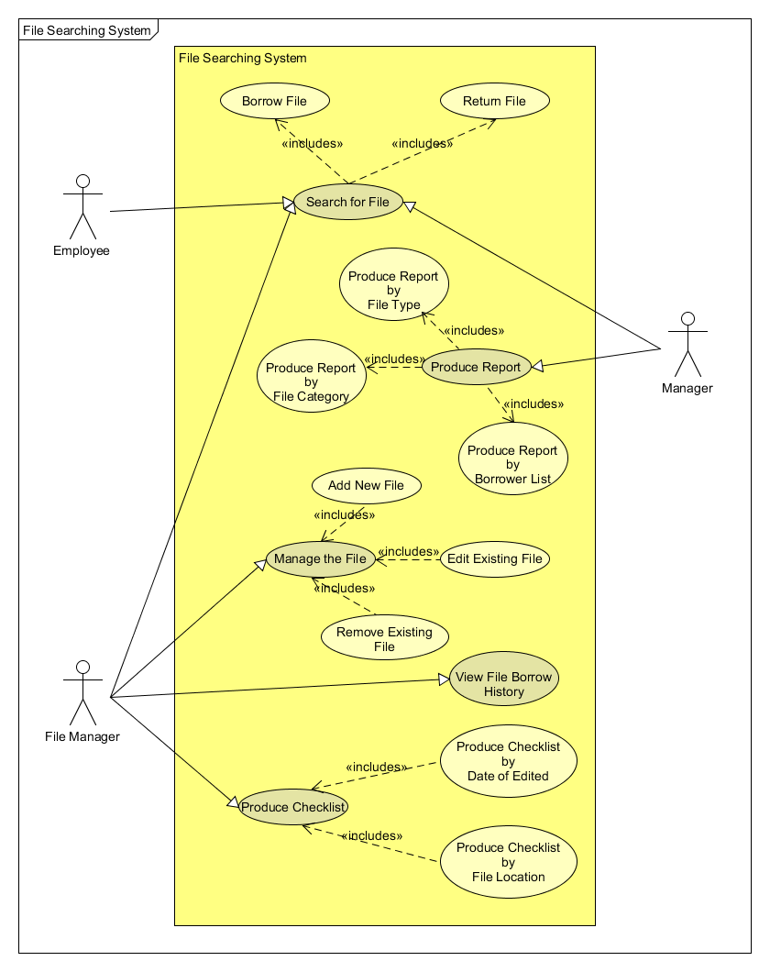

Figure 3: Use Case Diagram

## Sequence Diagram

### Search for File

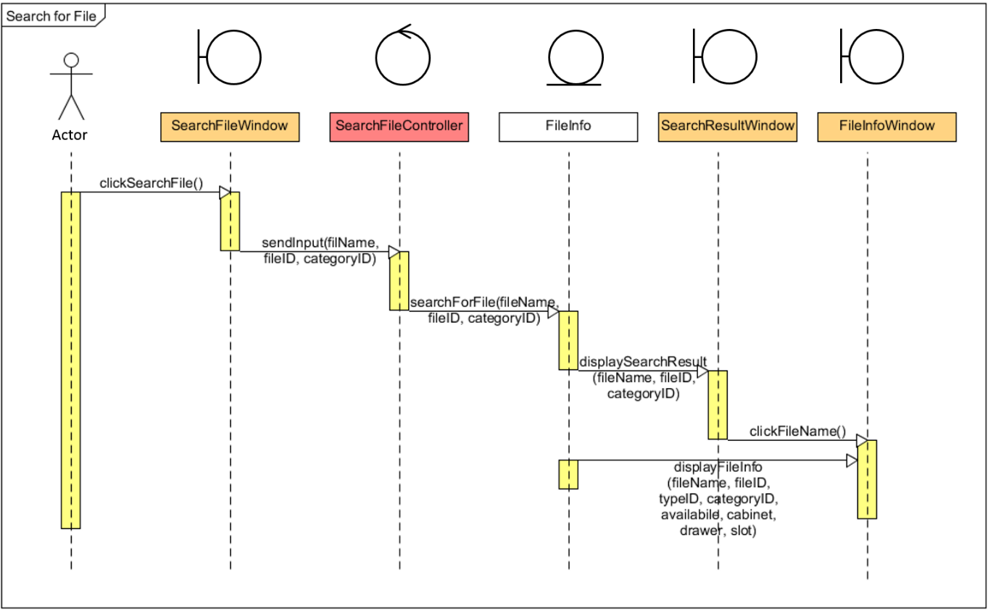

To search for the requested file, the figure above shows how the users, such as employee, manager, and file manager, need to click on the “Search File” button, then the system should direct the users to the “Search File” window. After submit the information in the search form, for example file name, file id, and file category, by the users, the system should display the result in terms of a list of related file. Next, the users click on the requested file name and the system should display the information of the requested file in the “File Information” window.

### Borrow File

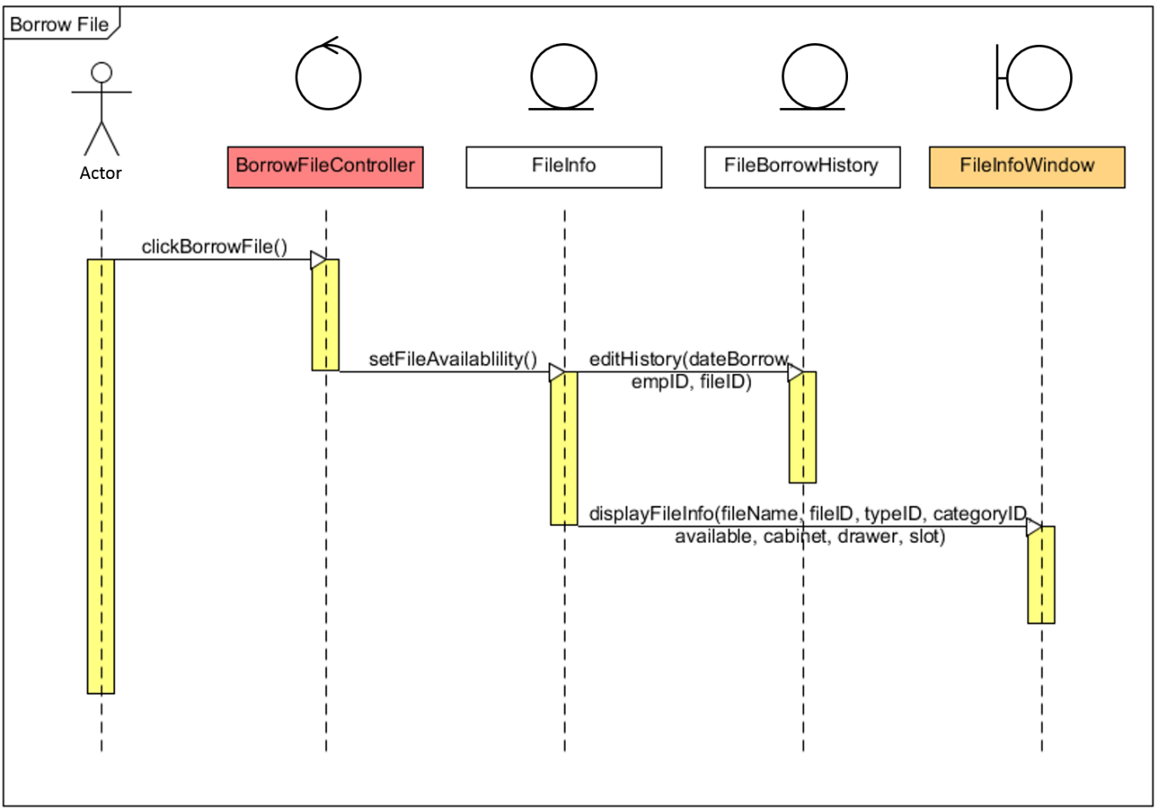

The sequence diagram above shows how the user such as employee, manager and file manager borrow the selected file. First they need to click on the “Borrow File” button on the “File Information” window. Then the system will sent the information to set the file available in the "File Info" database and add borrower history in the "File Borrow History" database. After done, "File Info" window will display the file information such as file name, file ID, type ID, category ID, availability, cabinet, drawer and slot of the file that user wants to borrow.

### Returning a File

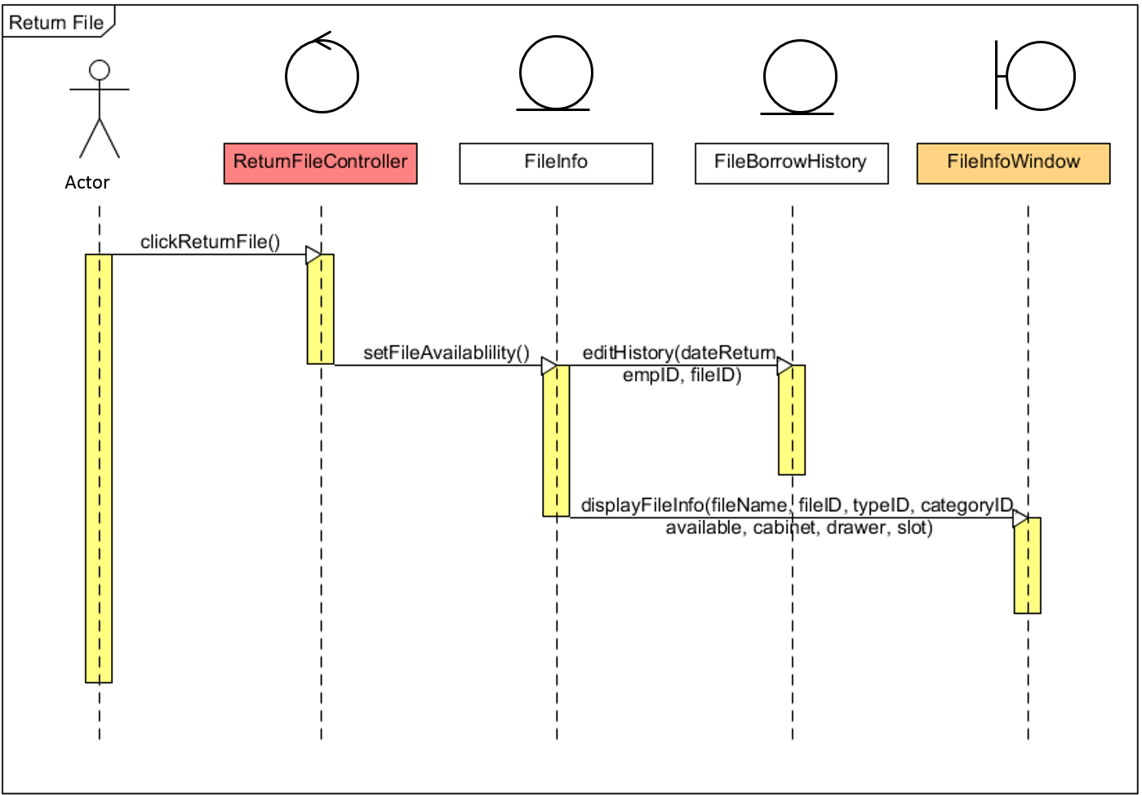

The figure above shows how the user want to return the file by click on the “Return File” button in the “File Information” window. Then, the system should update the borrower information in the database and direct the users back to the “File Information” window.

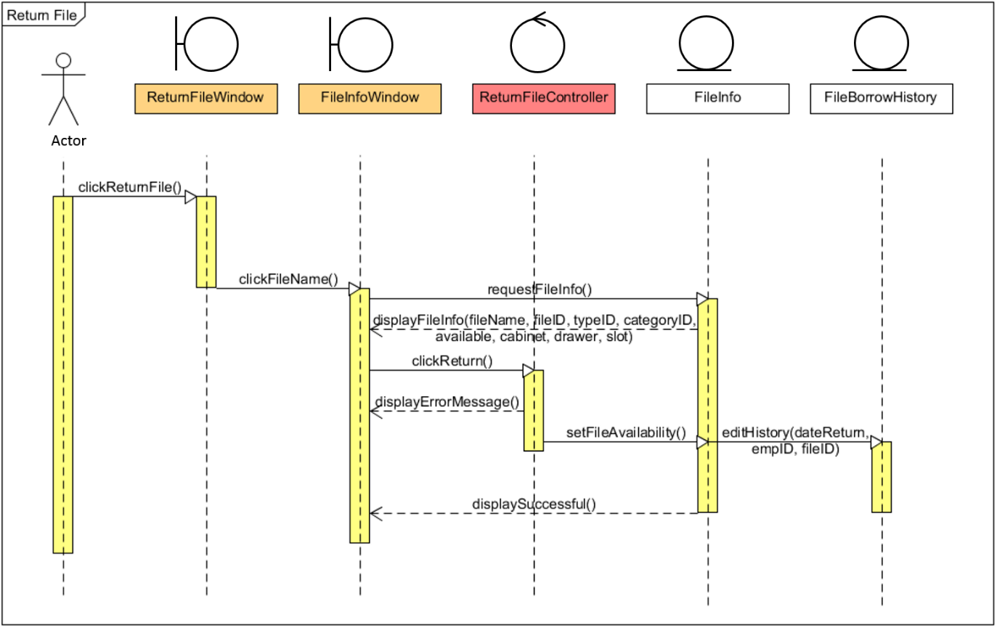

This figure shows the alternative way to return the file. First, the users need to click the “Return File” button in home view. Then, the system will direct the user to the “Return File” window which has a list of current borrowed file by the users. When the users click on the file name, the system should direct the users to the “File Information” window. Next, the process will undergoes the same process as the sequence diagram above.

### Produce Report by File Category

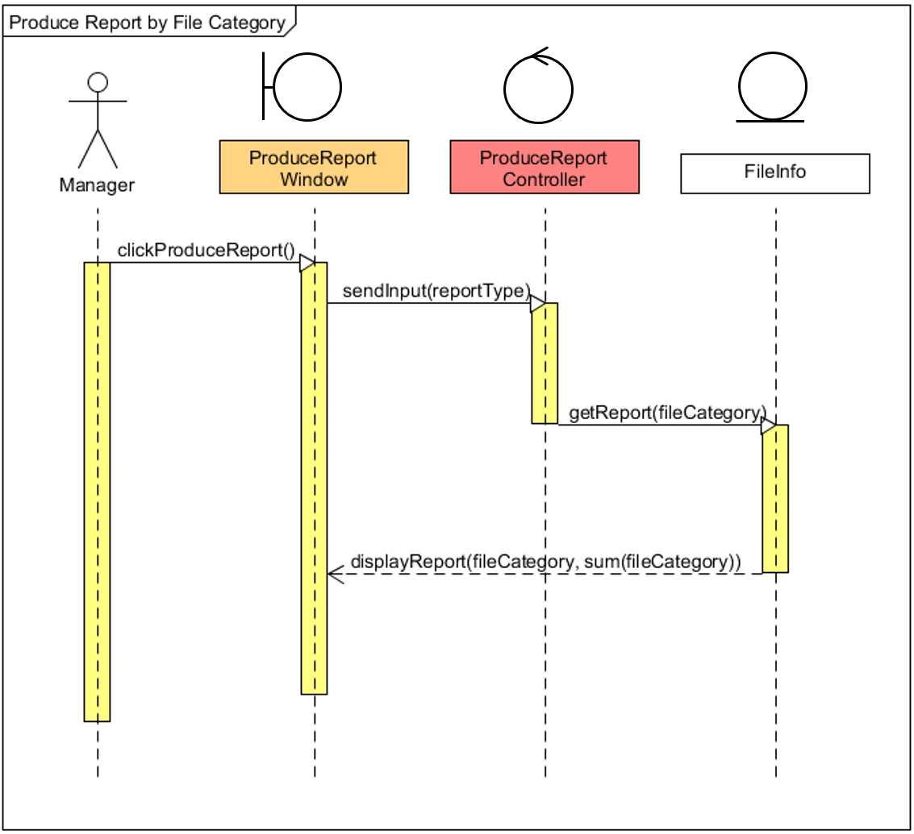

To produce report by file category, the sequence diagram above shows how the manager select “File Category” in the list of report type and click on “Produce Report” button. The system then will send the input of report type to generate a report of file category. After the system generates the report, it will display the associate report to the user. The report will view the table that contains the index of file category, and the sum of files of each category.

### Produce Report by File Type

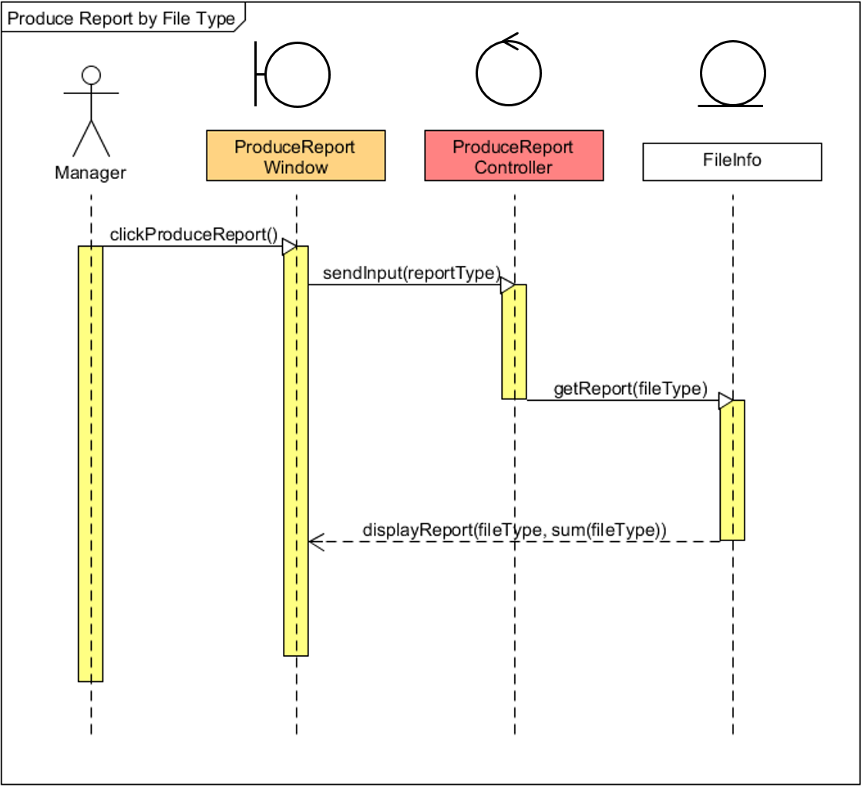

To produce report by file type, the manager start the sequence of diagram above by select “File Type” in the list of report type and click on “Produce Report” button. The system then will send the input of report type to generate a report of file type. After the system generates the report, it will display the associate report to the user. The report will view the table that contains the index of file type, and the sum of files of each type.

### Produce Report by Borrower List

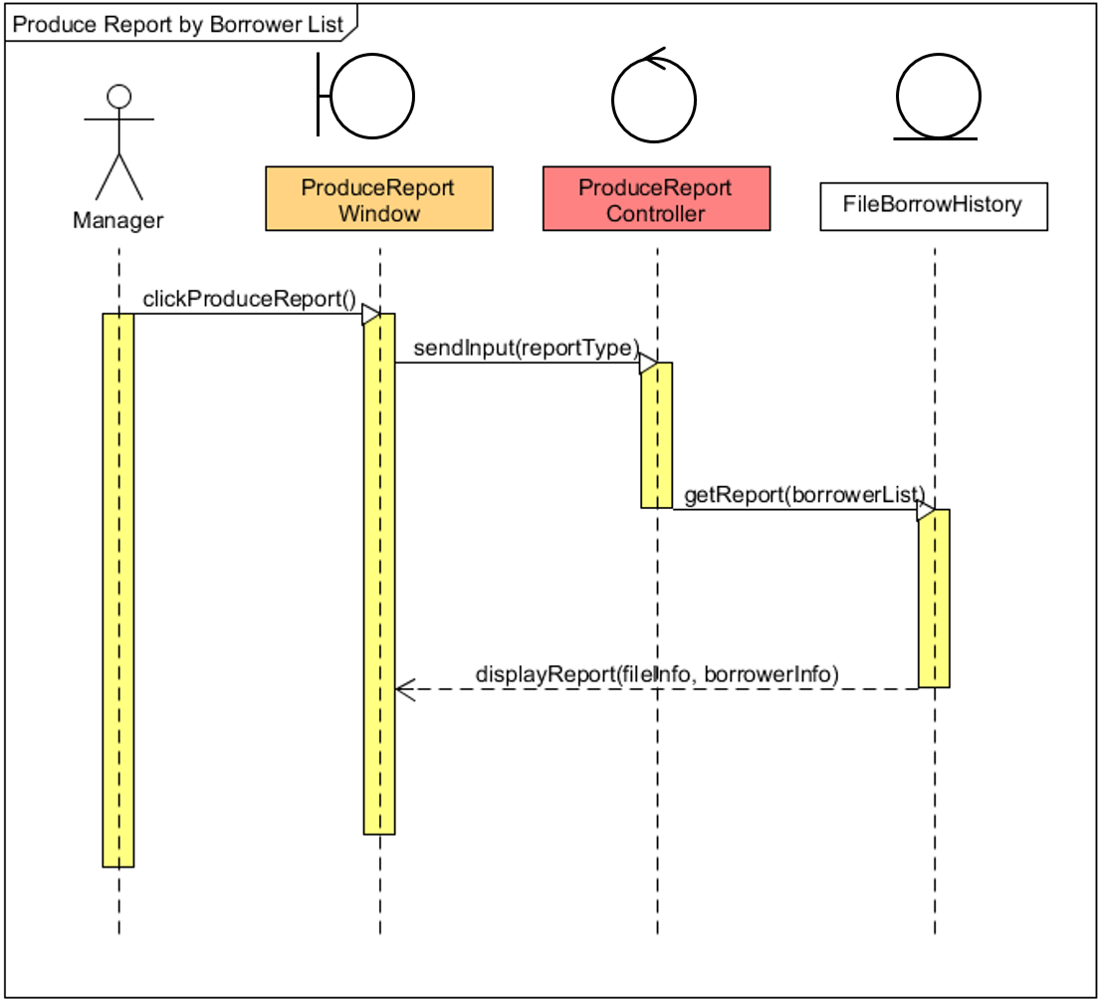

To produce report by borrower list, the manager start the sequence of diagram above by select “Borrower List” in the list of report type and click on “Produce Report” button. The system then will send the input of report type to generate a report of borrower list from the borrower’s history. After the system generates the report, it will display the associate report to the user. The report will view the table that contains the index of files that have been borrowed, file id, employee’s name, employee’s id, borrowed date, and returned date.

### Managing File by Adding New File

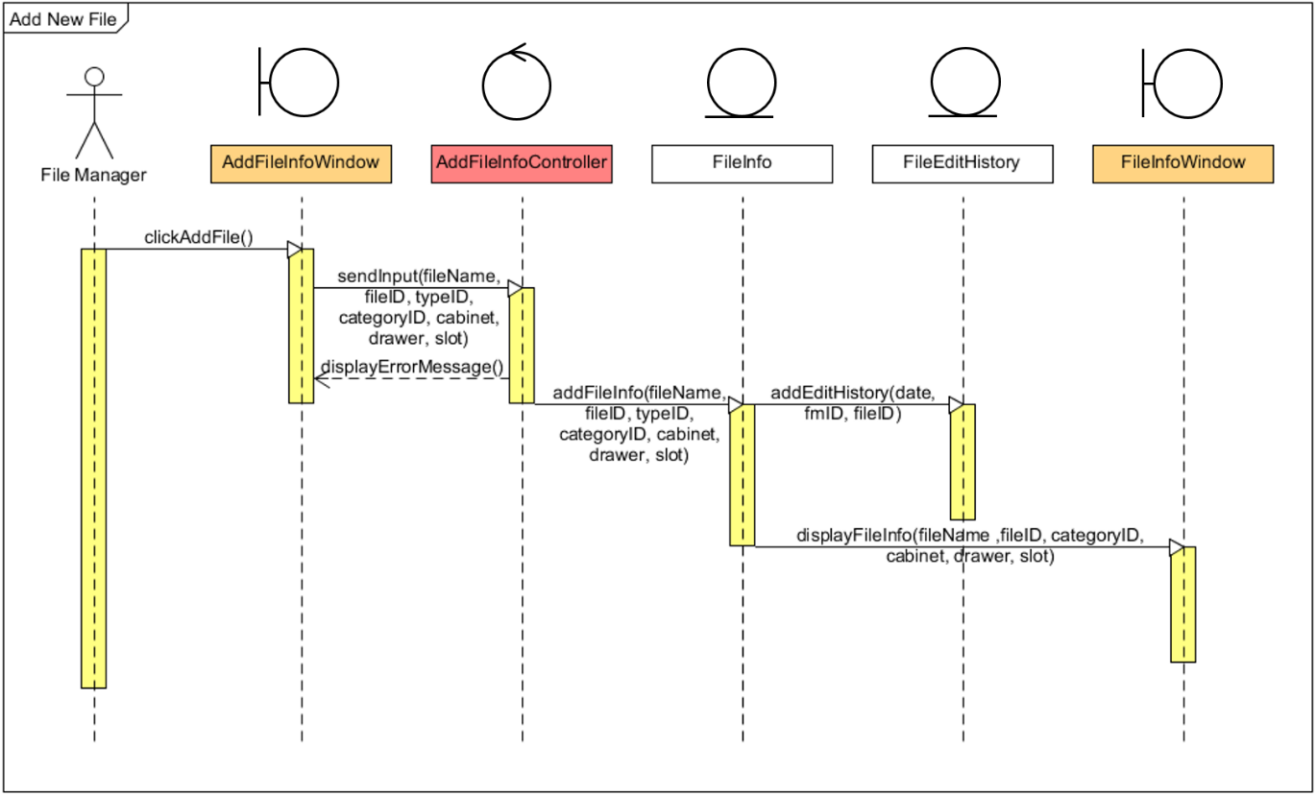

To add the file, the diagram above shows that the file manager need to click on the “Add File” button in the home view. Then, the system should direct the file manager to the “Add File” window. After the file manager has input the data in the input form, the system will create a new file information in the database. Lastly, the system will direct the file manager to the “File Information” window of the newly created file.

### Managing File by Edit Existing File

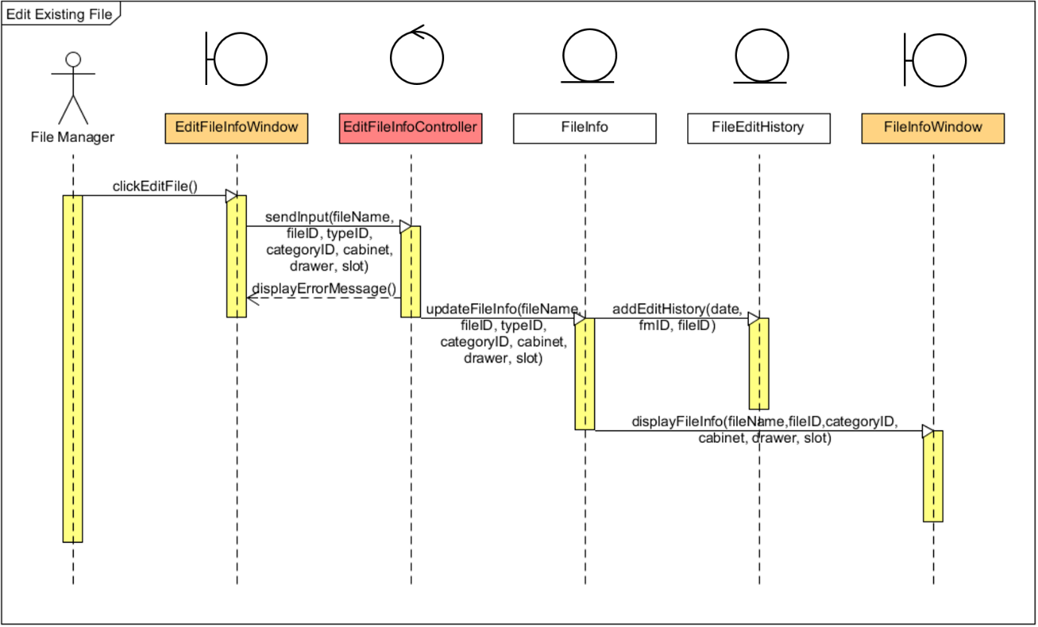

To edit the file, the file manager from the diagram above need to click on the “Edit File” button in the “File Information” window. Then, the system should direct the file manager to the “Edit File” window. After the file manager has change the data, the system will update the file information in the database. Lastly, the system will direct the file manager to the “File Information” window of the newly edited file.

### Managing File by Remove Existing File

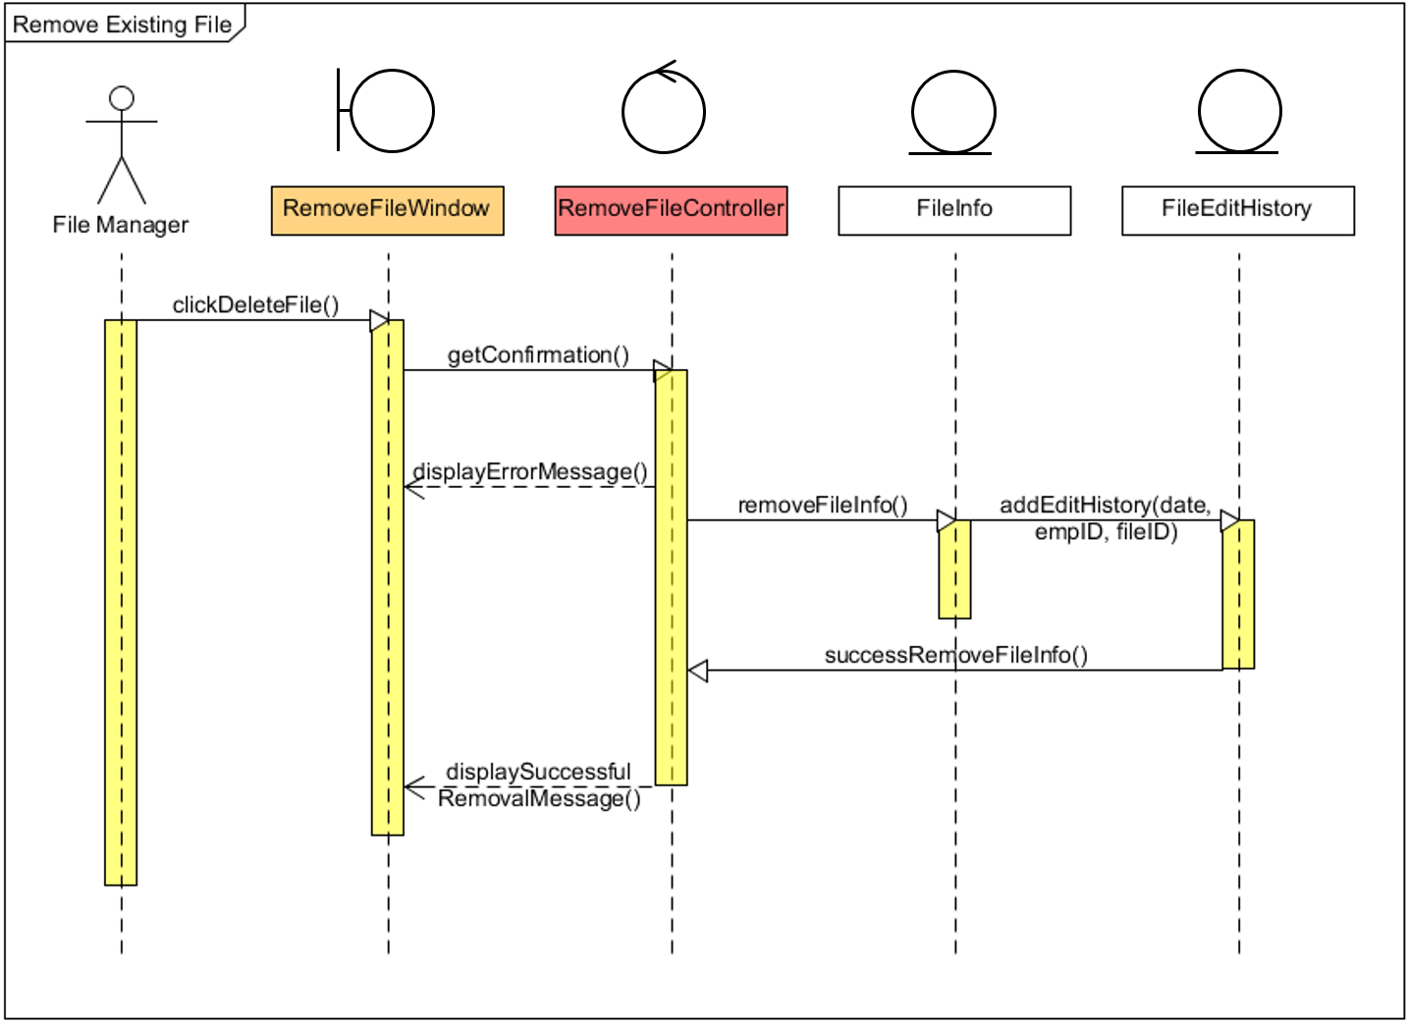

The sequence diagram above shows how the file manager managing file by remove existing file. First, the file manager select “Delete File” button on "Remove File" window and the system will get the confirmation to the "Remove File" controller. If the confirmation is refused, it will display error message to the window. If it confirm to remove the file, the system will sent the instruction to remove all the file information from the database and display the successful removal message to the file manager.

### View File Borrowed History

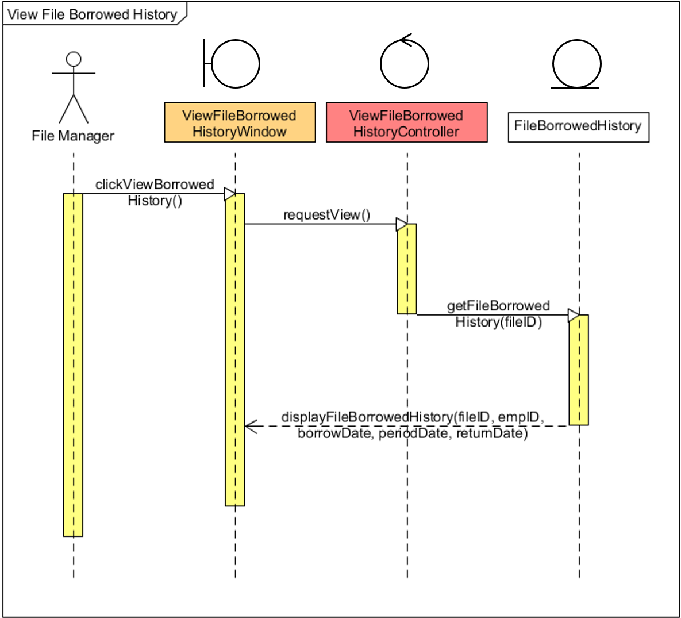

The figure shows the sequence diagram of how the file manager view file borrowed history. The file manager start with clicks on the “View Borrowed History” button on the “View File Borrowed History” window. After the request view sent to the system, the system will generate data from the database and sent it to the window to show the file borrowed history to the file manager.

### Produce Checklist by Date of Edited

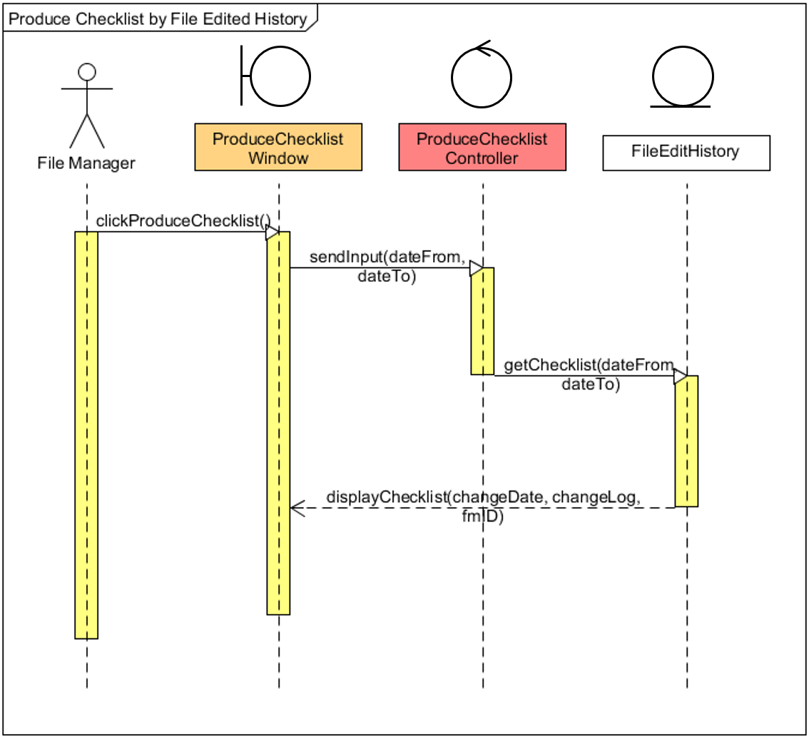

The figure above shows the sequence diagram of how the file manager produce the checklist by date of edited. The file manager begins when clicks on the “Produce Checklist” button in the home view, which direct the file manager to the “Produce Checklist” window. After set the interval of the date of edited, the system will display a list regarding the edit history of the file manager, such as add, edit, and remove file, according to the date interval.

### Produce Checklist by File Location

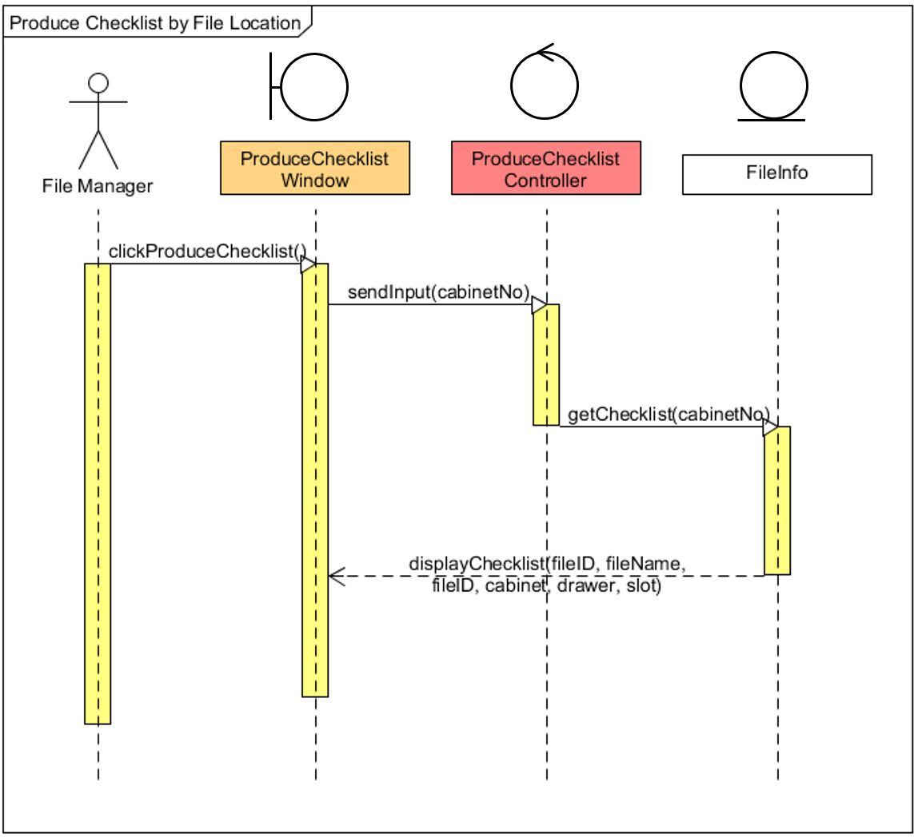

From the figure above, the file manager begins the sequence diagram when clicks on the “Produce Checklist” button in the home view, which direct the file manager to the “Produce Checklist” window. Then, the system will display a list of file in the slot of each drawer in a cabinet, according to the cabinet number input by the file manager.

## Class Diagram

### Class Diagram for Search for File

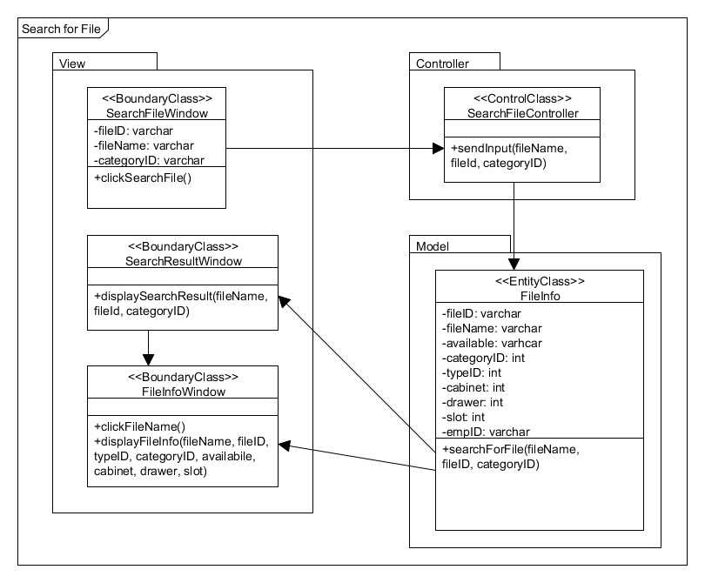

Figure 4: Class Diagram for Search for File

### Class Diagram for Borrow and Return File (Basic Flow)

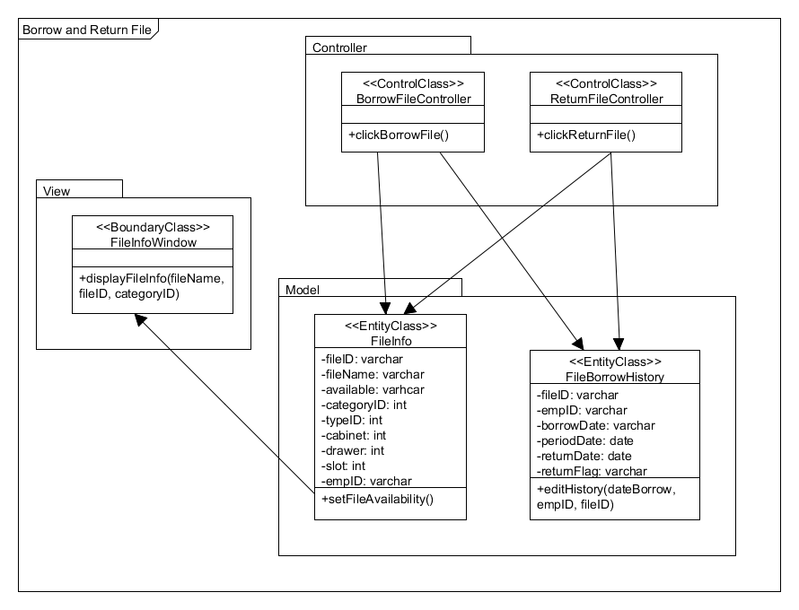

Figure 5: Class Diagram for Borrow and Return File (Basic Flow)

### Class Diagram for Return File (Alternative Flow)

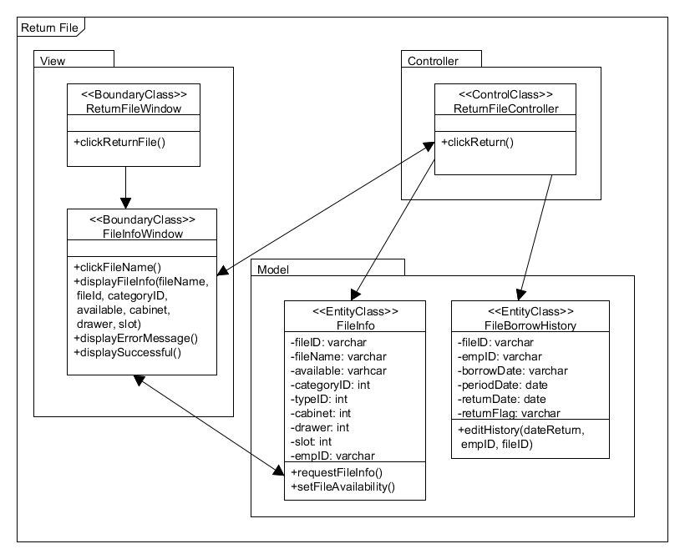

Figure 6: Class Diagram for Return File (Alternative Flow)

### Class Diagram for Produce Report

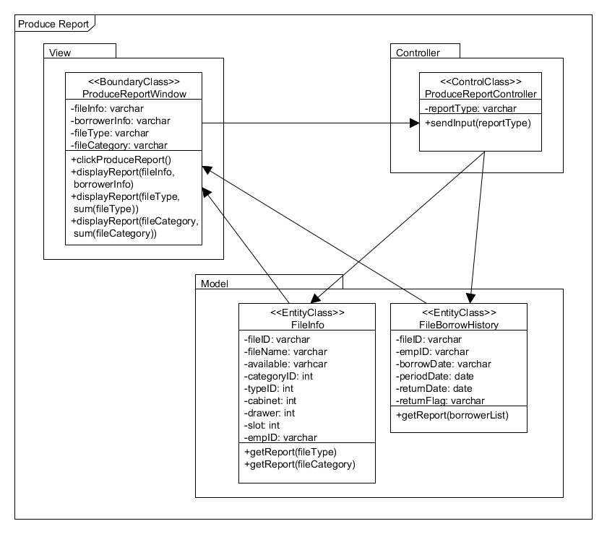

Figure 7: Class Diagram for Produce Report

### Class Diagram for Add New File

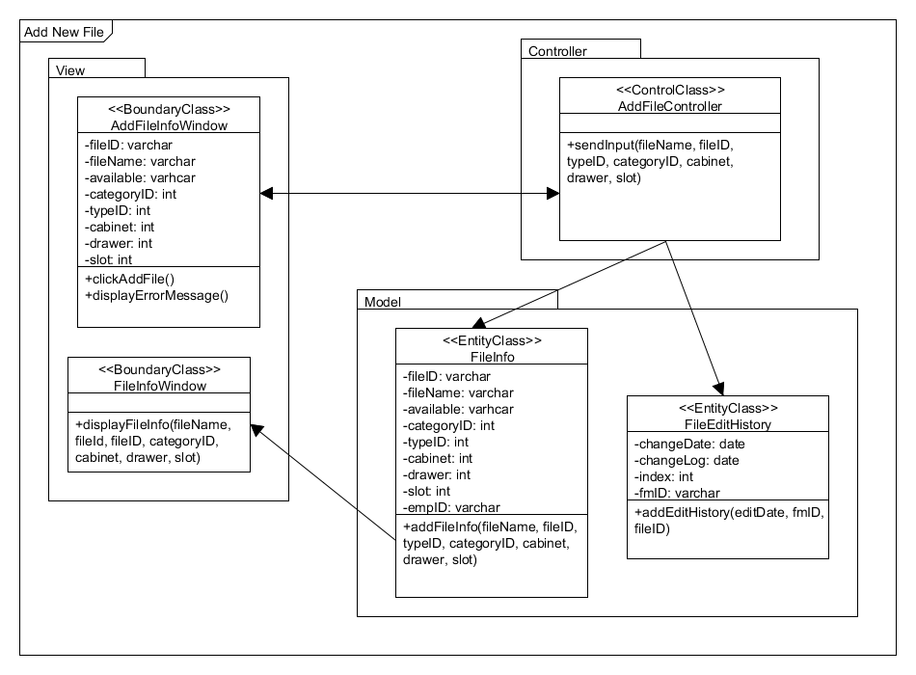

Figure 8: Class Diagram for Add New File

### Class Diagram for Edit Existing File

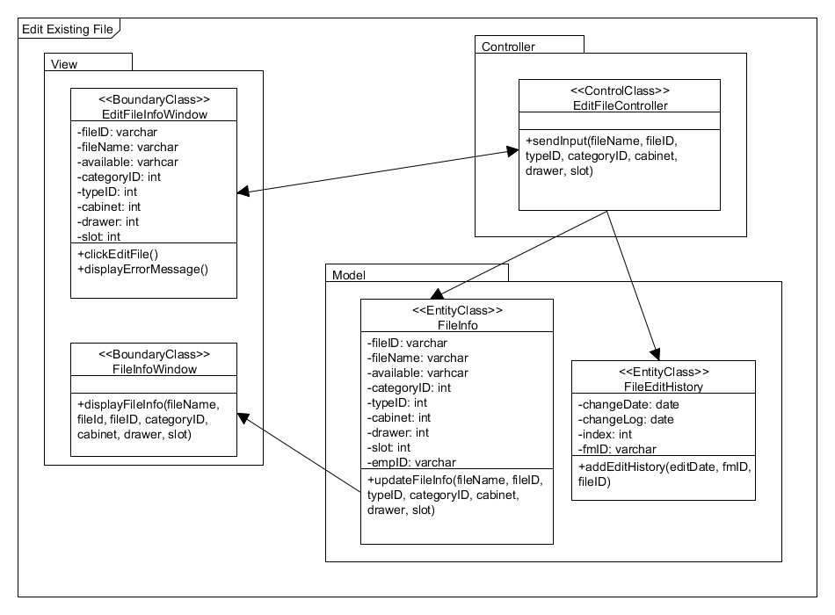

Figure 9: Class Diagram for Edit Existing File

### Class Diagram for Remove Existing File

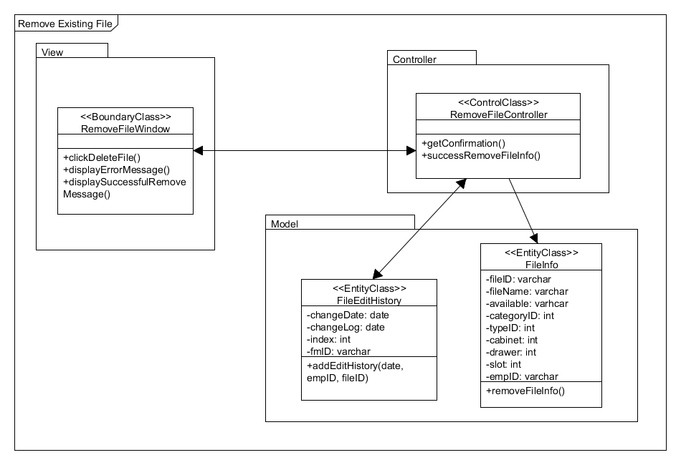

Figure 10: Class Diagram for Remove Existing File

### Class Diagram for View File Borrowed History

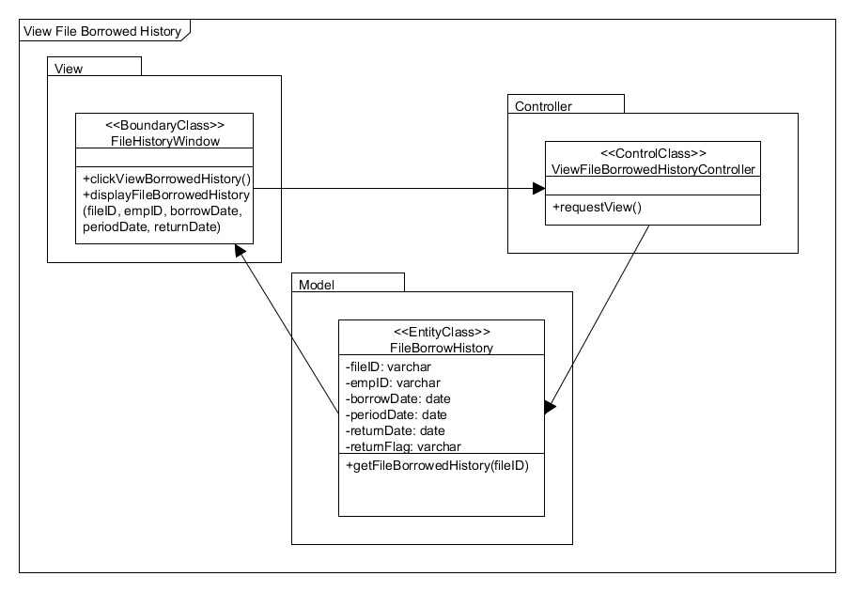

Figure 11: Class Diagram for View File Borrowed History

### Class Diagram for Produce Checklist

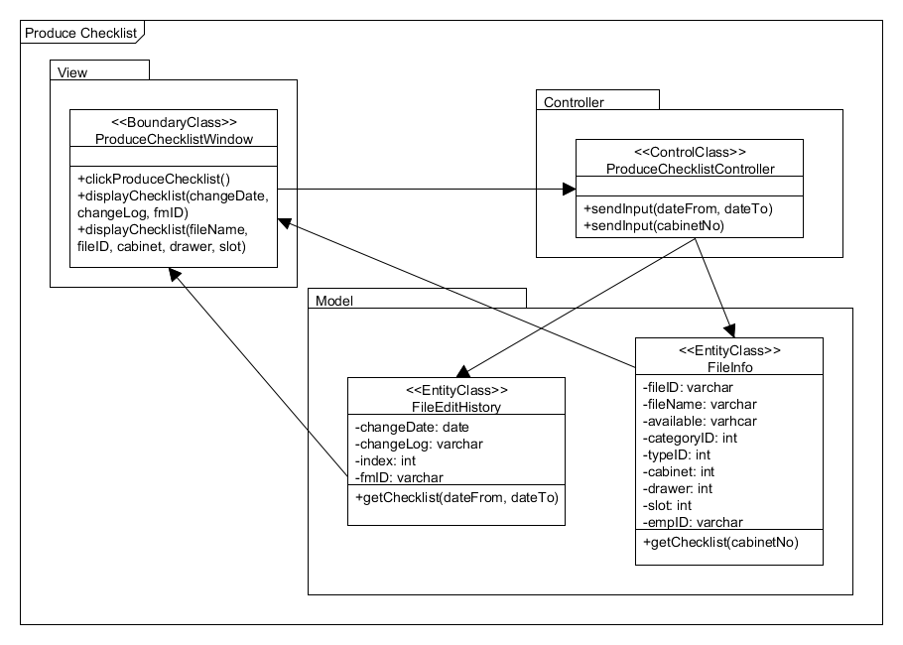

Figure 12: Class Diagram for Produce Checklist

## State Transition Diagram

### File State Transition Diagram for Borrow and Return File Scenario

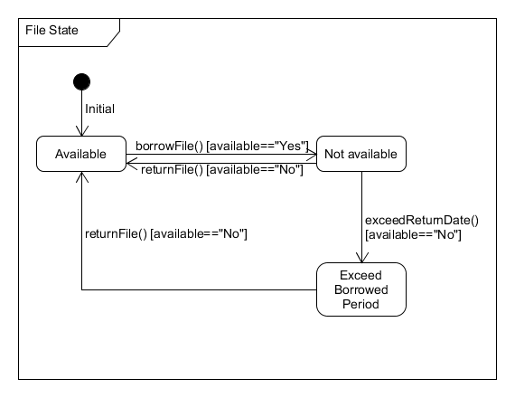

Figure 13: File State Transition Diagram for Borrow and Return File Scenario

### Borrowed File List State Transition Diagram for Borrow and Return File of Each User Scenario

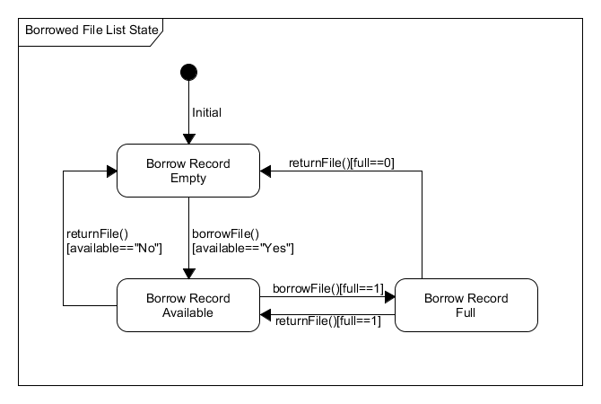

Figure 14: Borrowed File List State Transition Diagram for Borrow and Return File of Each User Scenario

### Search File State Transition Diagram for Searching File

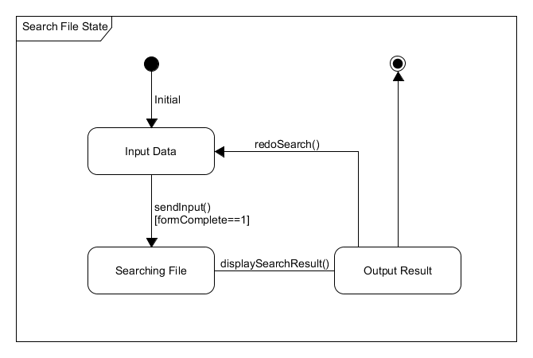

Figure 15: Search File State Transition Diagram for Searching File

### Add File State Transition Diagram for Add New File Scenario

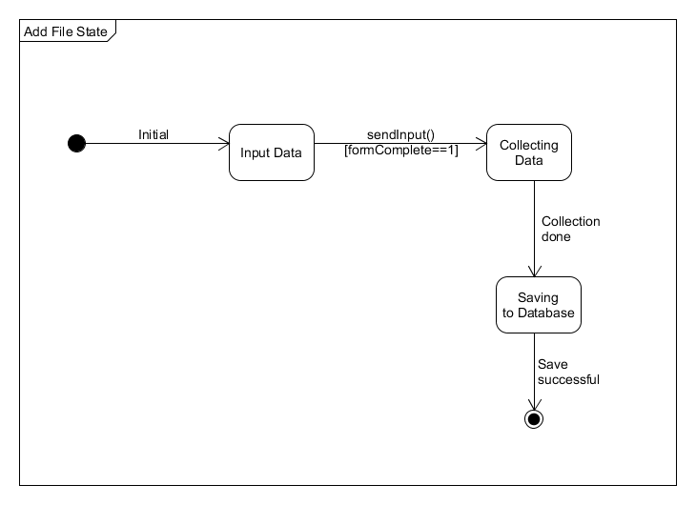

Figure 16: Add File State Transition Diagram for Add New File Scenario

### Edit File State Transition Diagram for Edit Existing File Scenario

Figure 17: Edit File State Transition Diagram for Edit Existing File Scenario

# User Interface Design

## Overview of User Interface

1. Function login

2. Home Page

2.1. Employee View

2.2. Manager View

2.3. File Manager View

3. Search File and Search Result

4. File Information Page

4.1 Employee and Manager View

4.2 File Manager View

5. Rented File Page

6. Produce Report Page

7. Add File Page

8. Edit File Page

9. Remove File Confirmation Box

10. View History Page

11. Produce Checklist Page

## Screen Images

### Login Page

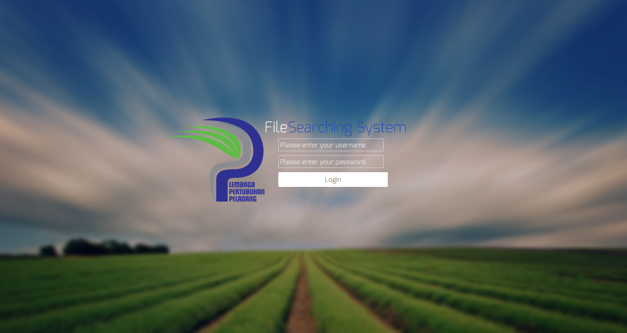

Figure 18

Figure 18 shows the login page of the file searching system. When the username and password is entered, the system will recognize whether the user is employee, manager or file manager based on the record in the created database. It will later redirect the user to the interface based on the user’s view.

### Home Page

#### Employee View

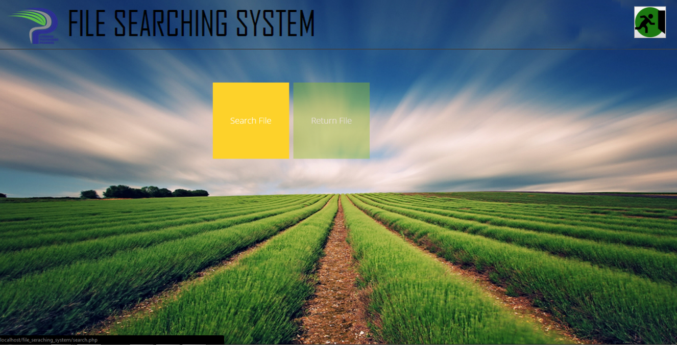

Figure 19

Figure 19 shows the main menu for the employee’s view. It has two tasks, which is Search File and Return File, which direct the user to Search File page and Return File page respectively.

#### Manager View

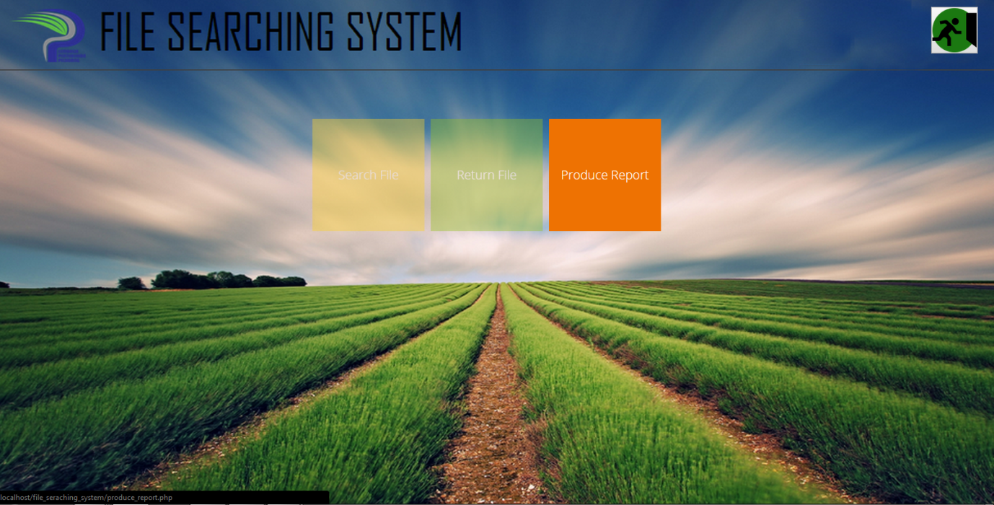

Figure 20

Figure 20 shows the main menu for manager’s view. Both the **Search File** and **Return File** have the same design and work logic as that in employee’s view. The only things that is different from employee’s file is the addition of **Produce Report** tasks.

#### File Manager View

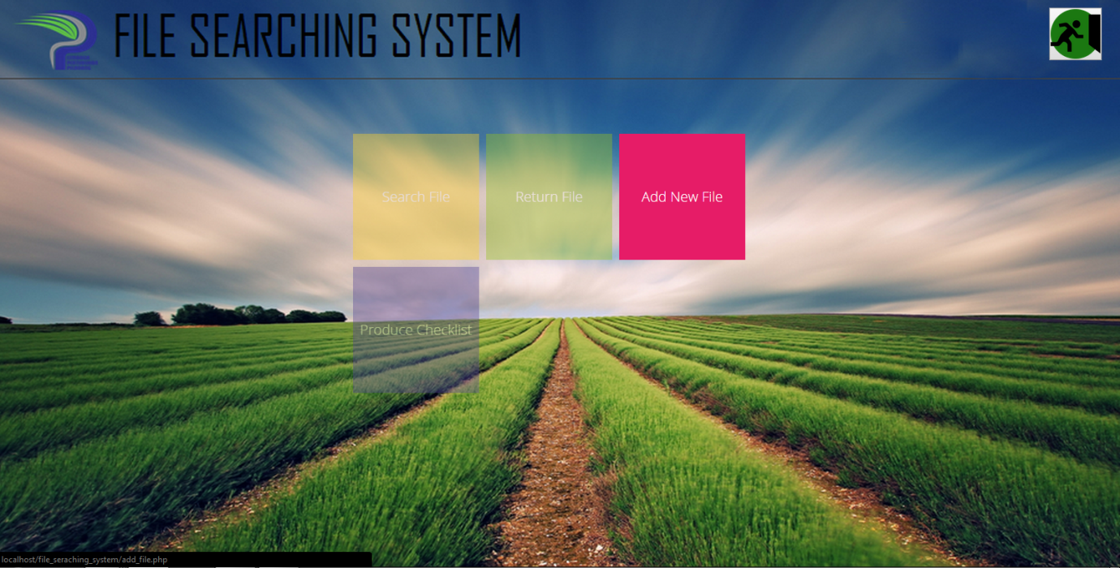

Figure 21

Figure 21 shows the main menu for the File Manager’s view. It has four tasks that is **Search File**, **Return File, Add New File** and **Produce Checklist**. Task **Search File** and **Return File** works exactly just like that in the employee’s and manager’s view.

### Search File Page and Search Result Page

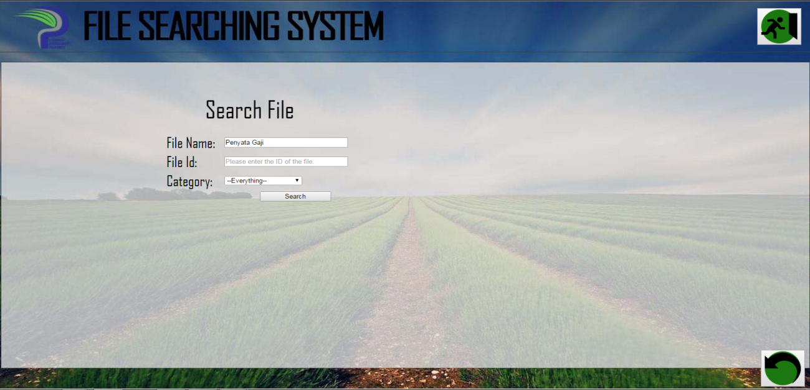

Figure 22

In the **Search File** **page**, the user can search the requested file based on the file name, file id and file category, by entering the value into the input form as shown in figure 22.

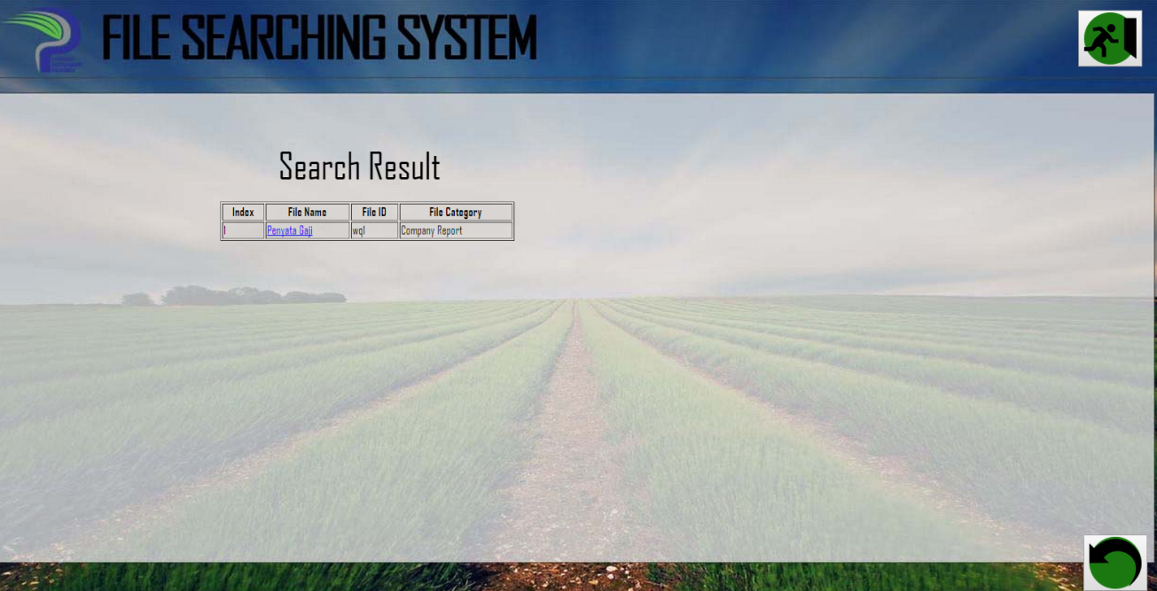

Figure 23

Figure 23 shows the **Search Result page**, which consists of a table of related file based on the value entered by the user in the form. User can see the file information by clicks on the file name that is acted as the hypertext.

### File Information Page

#### Employee and Manager View

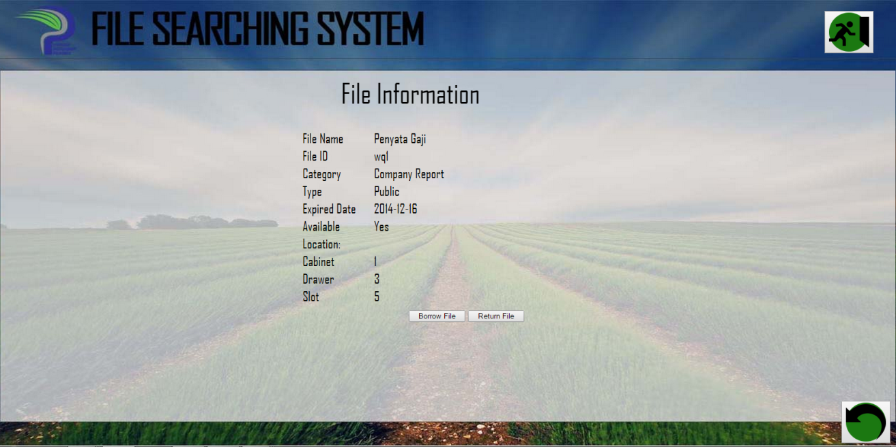

Figure 24

Figure 24 shows the **File Information page** which shows the output details of the file selected. In the output form, there are specified that the file is available or not. If the file is available, then the user can borrow the file by clicking the **Borrow File** button.

#### File Manager View

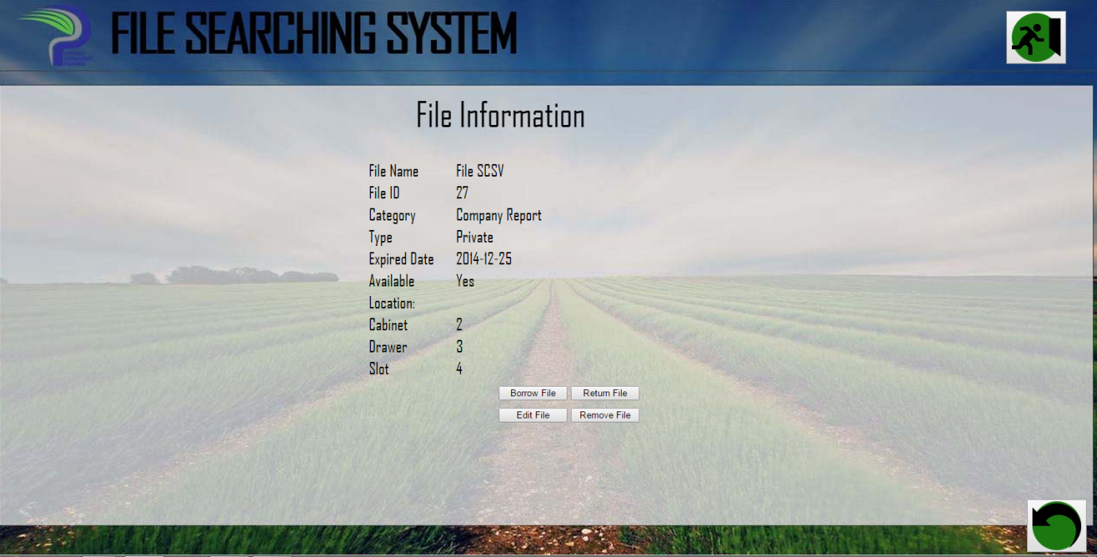

Figure 25

Different with the other user’s view, in File Manager’s view there are three additional button, that is **Edit File** button, **Remove File** button and **View History** button, in the **File Information page**, as shown in figure 25. If the file manager click **Edit File** button, it will direct the user to the **Edit File page**.While **Remove File** button is choosed, there will come out a confirmation box to ask the user whether he/she want to remove the file from the system. And if the **View History** button is choosed, all the borrower history of the file will be shown.

### Rented File Page

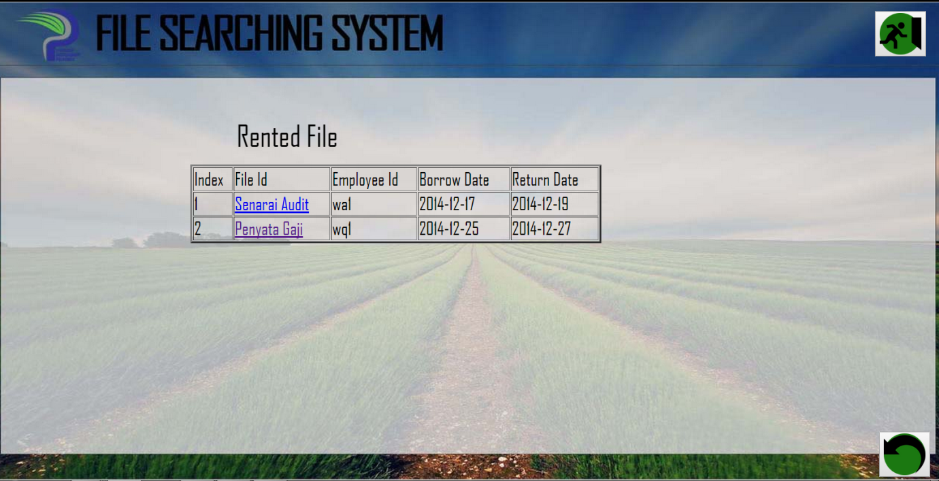

Figure 26

Figure 26 shows the **Rented File page**, which allow the user to see the table of file that is currently rented by him/her. The user can look into the details of the file by clicks on the file name that is acted as the hypertext, which will direct the user to the **File Information page**.

### Produce Report Page

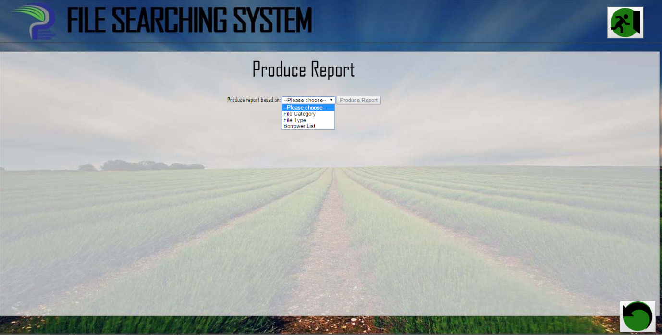

Figure 27

In the Produce Report page, manager can choose what report to generate based on the option in the dropdown box, as shown in figure 27. If the manager choose File Category, the report based on the number of each category is generated (see figure 28). If the manager choose File Type, the report based on the number of each file type is produced (see figure 29).If the manager choose Borrower List, the report based on the borrower and the file borrowed is generated (see figure 30).

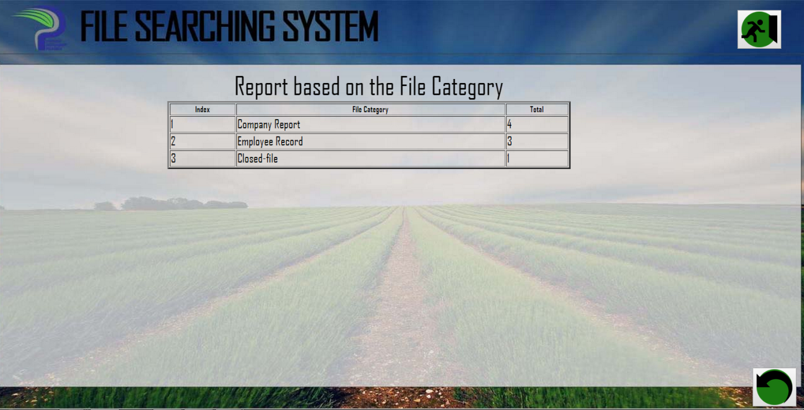

Figure 28

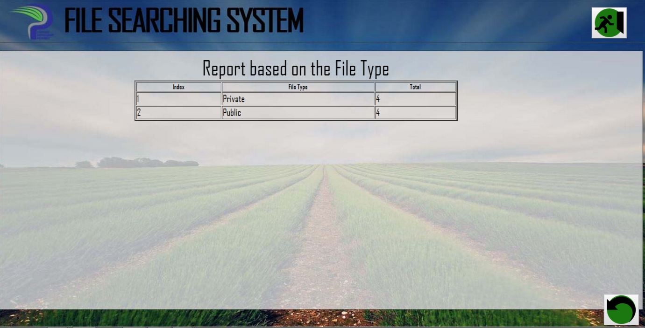

Figure 29

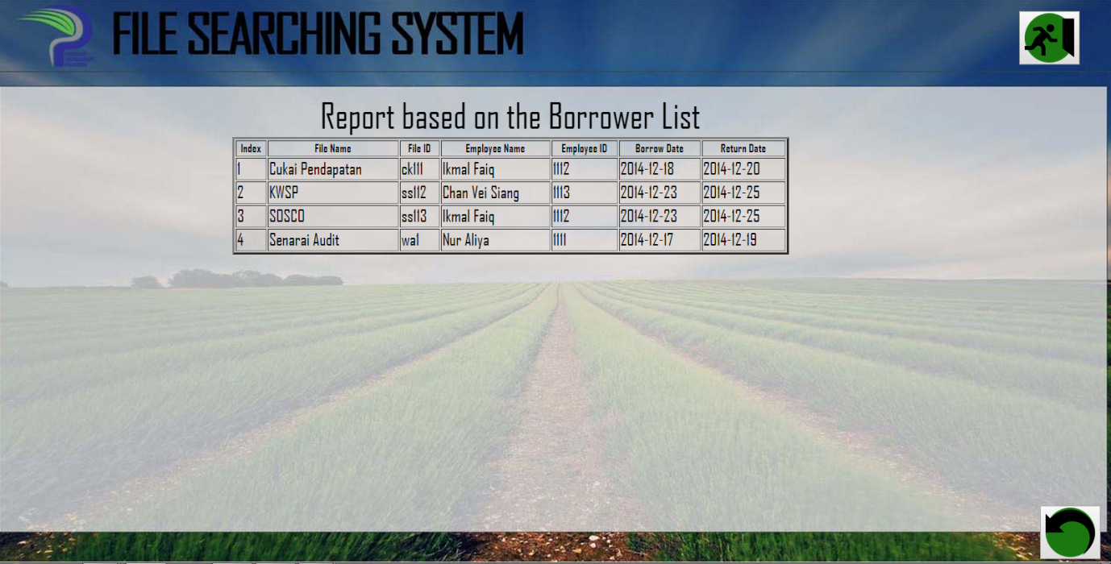

Figure 30

### Add File Page

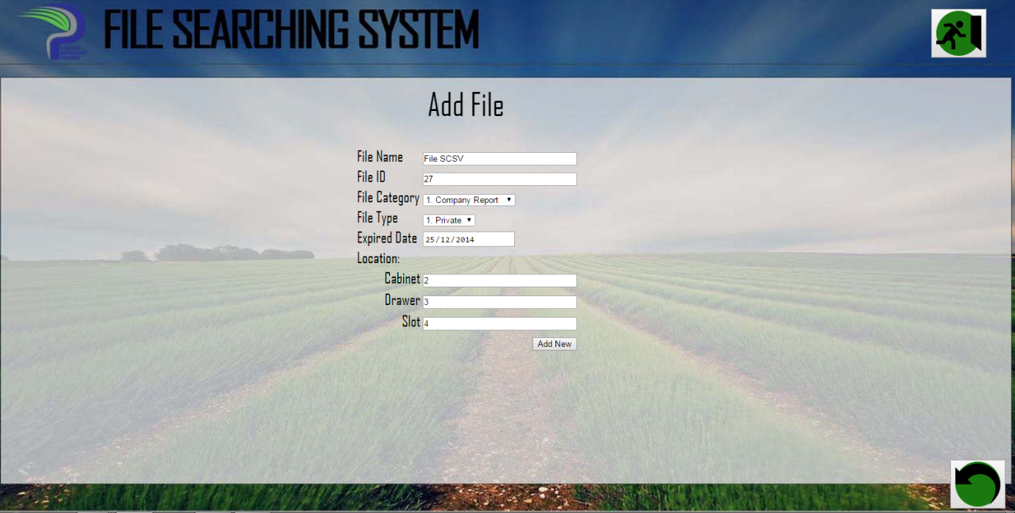

Figure 31

In the **Add File page**, the file manager can enter all the details in the input form as shown in figure 31, in order to add new file into the FSS.

### Edit File Page

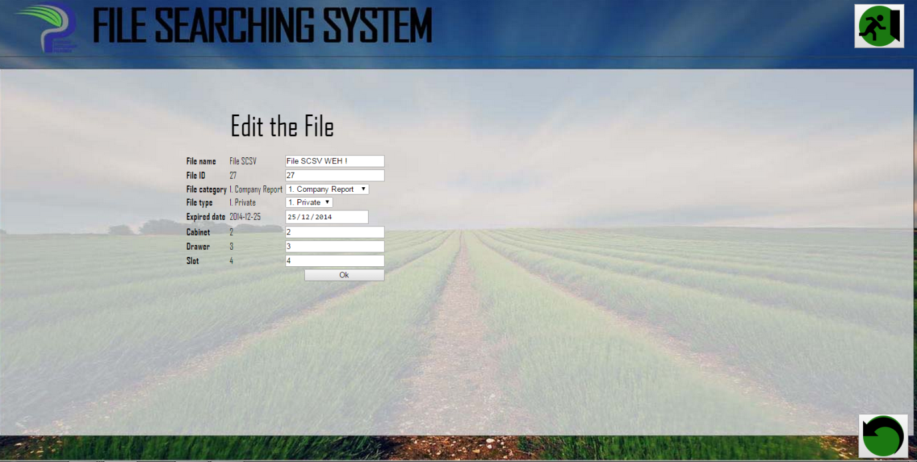

Figure 32

In the Edit File page, file manager can edit all the file information. By clicking Ok button, it automatically will save all the edited information as in Figure 32.

### Remove File Confirmation Box

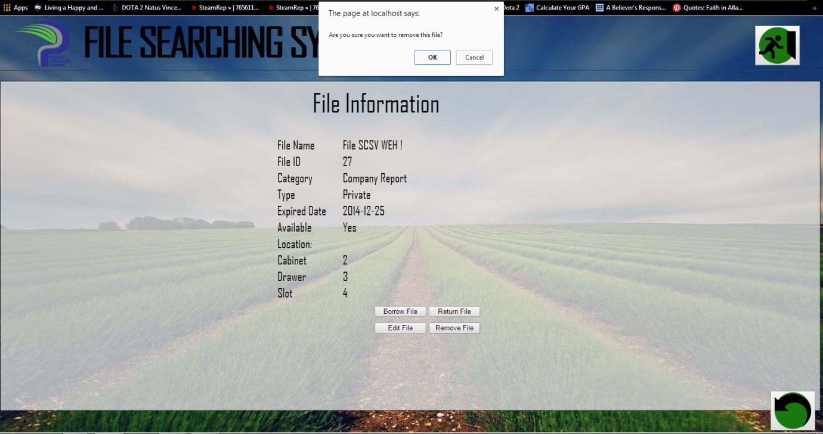

Figure 33

Based on Figure 33, while **Remove File** button is choosed, there will come out a confirmation box to ask the user whether he/she want to remove the file from the system.

### View History Page

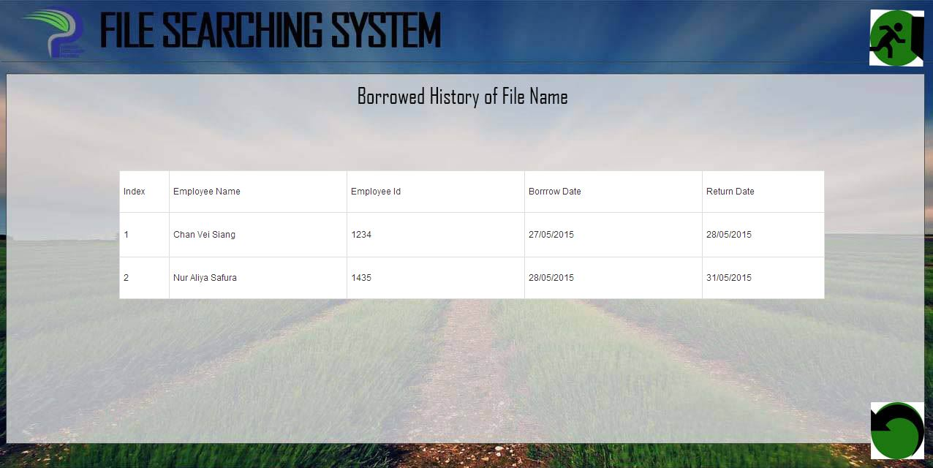

Figure 34

The **View History page** will view all the borrower history of the selected file, which is displayed in the form of table. The informations displayed are the past borrower’s name, employee id, borrow date and actual return date.

### Produce Checklist Page

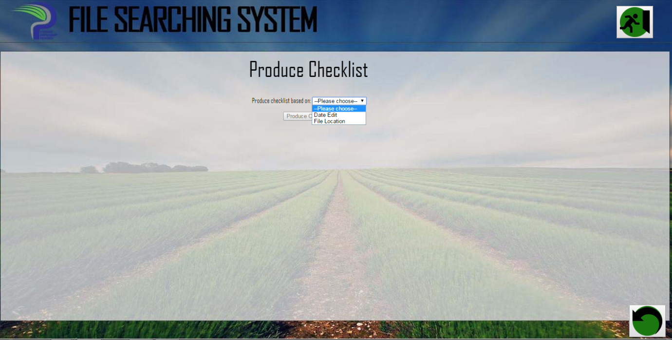

Figure 35

In the **Produce Checklist page**, File Manager can choose what checklist to generate based on the option in the dropdown box, as shown in figure 32. If the File Manager choose **Date Edit**, the system will require the range of time from the user (see figure 33) to produce checklist based on the date of edit .And if the file manager choose **File Location,** the system will require the cabinet number (see figure 34) . After the cabinet number is entered, the system will show the list of file in the cabinet (see figure 35).

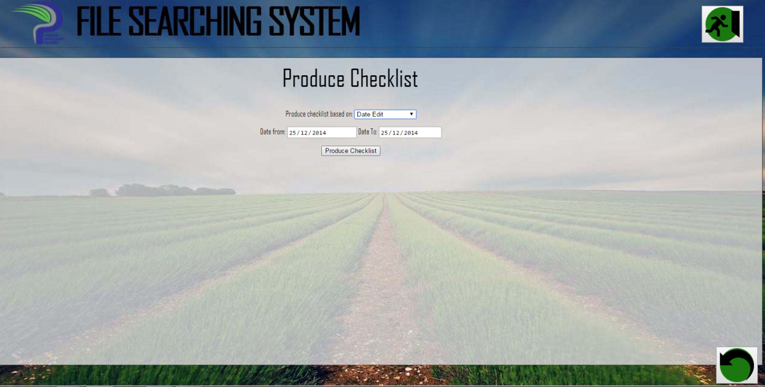

Figure 36

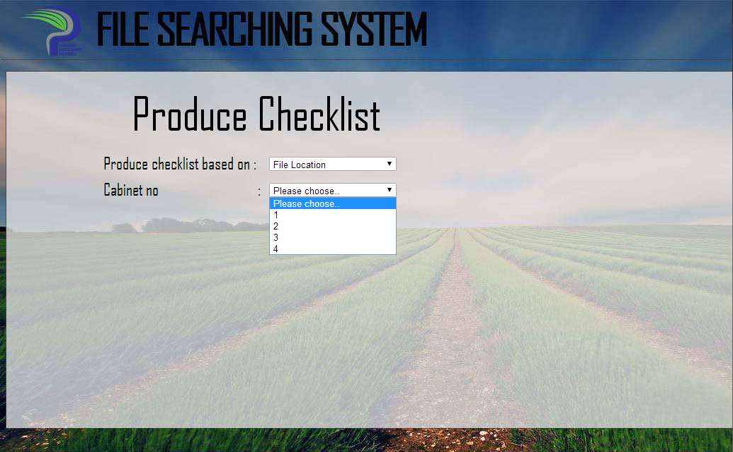

Figure 37

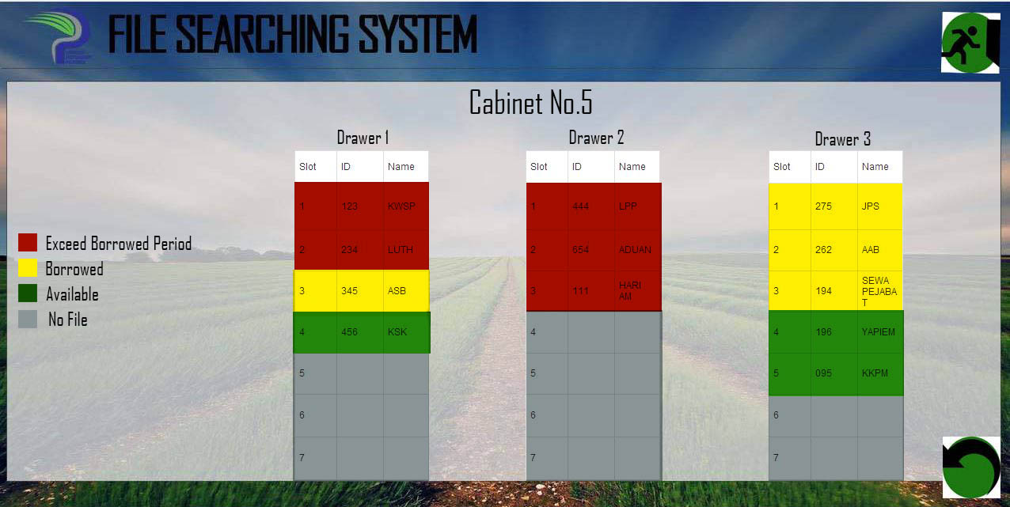

Figure 38

# Appendices

The figures below are the example page of the log book used by the LPPKJBT to search the file manually. The list contain the name of file as well as the serial number of the file.

